

The 10th Annual
Otis Invitational

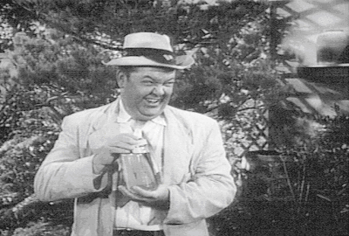
June 22, 23, 24 - 2007

Hosted By
Timber Ridge Golf Club
Trout Lake Golf Club
Northwood Golf Club

www.svs.com/zim/otis
 $6.75 
10th Annual Otis Invitational

Welcome Otis Participants!

This program will become your Otis bible, containing and pertaining to everything you could want to know about the tournament.

The most important rule, as always is to have a great time.

And in addition to the rules, this program contains prize money info, format, tee times, logistics, and of course, the now infamous Player Bios.

The logistics section includes directions, multiple maps, and for those of you who enjoy taking the back-roads, phone numbers for when you get lost.

Our final count for 2006 is at 40 players.

If you cannot play, let us know immediately, so we can fill your spot. Uneven scramble teams are no fun for anybody. Also, we have already committed to bring 40 people, and deposits have been paid. If we can’t replace you, you may not get a refund.

Make sure you reserve your room at the AmericInn. Call them at 715-356-3306. Rooms are approx. $99 per night double occupancy. Each room will have 2 double beds. To Reserve your room, call immediately for the Otis Golf Outing.

Tee times begin at 7:15 AM on Friday, 7:20 AM on Saturday and 7:20 AM on Sunday. Please make sure you get to the course ahead of time. Please show up for the first tee time even if you are not teeing off first. We are starting in a shotgun format all 3 days in the morning.

Soft spikes are probably required, so bring a replacement set of spikes if you still use the metal ones.

Tee Markers: We will play the white tees for the entire weekend for all 5 rounds.

We will have a group dinner on Saturday at the Thirsty Whale in Minocqua. We hope everyone will participate. The dinner price is included in your entrance fee, and includes appetizers, salad, breadsticks, dinner entree, dessert, and the tip. Cash bar.

We will also be meeting in the bar at the T. Murtaughs in Minocqua on Thursday (after 9:00 p.m.) if you are interested in meeting up with many of the participants before the tournament. See map at the end of the program for more info on T. Murtaughs.

The Prizes will be distributed as follows:

Closest To The Pin (4 holes per round, all 5 rounds) $30
Long Drive (1 hole per round, all 5 rounds) $30

Long Putt (2 holes per morning round) $30

Long Putt (2 holes per afternoon round) $30

Low Net 1st place (one person, each stroke play round) $60
Low Net 2nd place (one person, each stroke play round) $55
Low Net 3rd place (one person, each stroke play round) $50
Low Net 4th place (one person, each stroke play round) $45
Low Net 5th place (one person, each stroke play round) $40
Low Net 6th place (one person, each stroke play round) $35
Low Net 7th place (one person, each stroke play round) $30
Low Net 8th place (one person, each stroke play round) $25
Low Net 9th place (one person, each stroke play round) $20
Low Net 10th place (one person, each stroke play round) $15
Low Net 11th place (one person, each stroke play round) $10
Low Net 12th place (one person, each stroke play round) $5

Scramble Team Winners (each person, each scramble round) $60
Scramble Team 2nd place (each person, each scramble round) $50
Scramble Team 3rd place (each person, each scramble round) $40
Scramble Team 4th place (each person, each scramble round) $30
Scramble Team 5th place (each person, each scramble round) $20
Scramble Team 6th place (each person, each scramble round) $10

The golf fees for all 5 rounds will be $182 per person (includes green fees and riding cart.
Betting / prize / Saturday dinner money is $183 for the entire weekend.

Total cost per person: $365 (not including the hotel room.)

Birdie pool is no longer optional. (It is too hard to keep track of who is in and who is out…) You will pay $1 for every birdie made by others, and receive $1 from everyone else if you make a birdie. If someone scores an eagle, it will be counted as 2 birdies. A hole in One or a double eagle will count as 3 birdies. (Ya never know....)

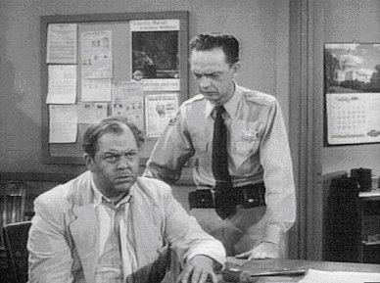

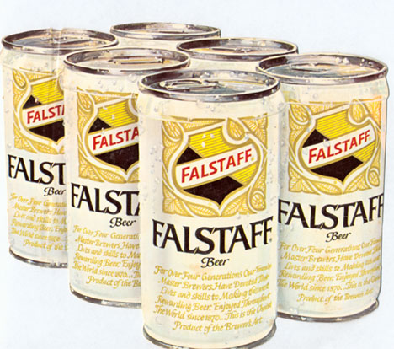

2007 Otis Invitational
Official Otis Format

Friday AM - Stroke play with your foursome at Timber Ridge. Prizes are awarded for the 4 closest to the pin markers, long drive in the fairway on #18, longest putt made on #9 & #18, and to the top 12 finishers. White tees. Free Range Balls!

Friday PM – 4 man scramble play at Timber Ridge. Teams are determined by a high/low pairing based on your pre-tournament approved score. For example, each team would consist of players ranked in the A, B, C, and D tiers (to be determined ahead of time.) Prizes are awarded for the 4 closest to the pin markers, long drive in the fairway on #18, longest putt made on #9 & #18, and to the top 6 teams. White tees. Free Range Balls!

Saturday AM - Stroke play with your foursome at Trout Lake. Prizes are awarded for the 4 closest to the pin markers, long drive in the fairway on #9, longest putt made on #9 & #18, and to the top 12 stroke play finishers.
White tees. Free Range Balls!

Saturday PM - Handicapped 4 man scramble play at Trout Lake. Teams are determined by a drunken draw with an A, B, C and D player. Handicaps are computed based your pre approved average score. Prizes are awarded for the 4 closest to the pin markers, long drive in the fairway on #18 (a fun shorter hole), longest putt made on #9 & #18, and to the top 6 teams. White tees. Free Range Balls!

Sunday AM - Handicapped 4 man scramble play at Northwood. Teams are determined by a method to be announced. Handicaps are computed based your pre approved average score. Prizes are awarded for the 4 closest to the pin markers, long drive in the fairway on #18, longest putt made on #9 & #18, and to the top 6 teams. White tees.
Official Otis Logistics

Tournament Date: Weekend of Friday, June 22, 2007

Tournament Location: Timber Ridge Golf Club (Friday)
Minocqua, Wisconsin (715) 356-9502

Trout Lake Golf Club (Saturday)
Arbor Vitae, Wisconsin (715) 385-2189

Northwood Golf Club (Sunday)
Rhinelander, Wisconsin (715) 282-6565

Motel Accommodations: AmericInn of Minocqua
700 Highway 51 North – Minocqua, WI 54548
Rooms are $99.90 per night double occupancy.
Each room will have 2 double beds.
Block of rooms reserved under the Otis Golf Outing

Saturday Night Dinner: We will have the entire group eat together at the Thirsty Whale in Minocqua on Saturday night. Your Saturday dinner is included in the entry fee. For other meals, you are on your own. There are many good spots to eat around the hotel.

Tournament Format: 36 Holes on Friday and Saturday, 18 Holes on Sunday

Cost Breakdown: Greens Fees are $182 for the entire weekend. This includes 90 holes of golf,
($365 Total per person) and a riding cart. Betting, Prize and Dinner money is $183 for the entire weekend.
(for closest to the pin, low net, long drive, long putt, scramble winners, the dinner, and other goodies.)
Birdie pool is mandatory. You will pay $1 for every birdie made by others, and receive $1 from everyone else for each birdie you make. Please send all checks to Rob Westover, 765 Dogwood Lane, Lake In The Hills, IL 60156.

Tee Times: Begin at 7:15 on Friday, 7:20 on Saturday, and 7:20 am on Sunday.

Player Handicaps: Your handicap will be determined by a mutually agreed upon average score.
If you have not played with us before, you will need to agree on a score with
someone who has. We will adjust your score up or down if we determine that
you normally play a very easy or difficult course. We ask you to be honest. The
competition will not be very much fun if there are a lot of “sandbaggers”.

Other information call Jason Zimberoff at 630-879-7761
Mike Redenbaugh 630-337-3839
Bump Waghorne at 630-736-8170
Rob Westover at 847-854-6625
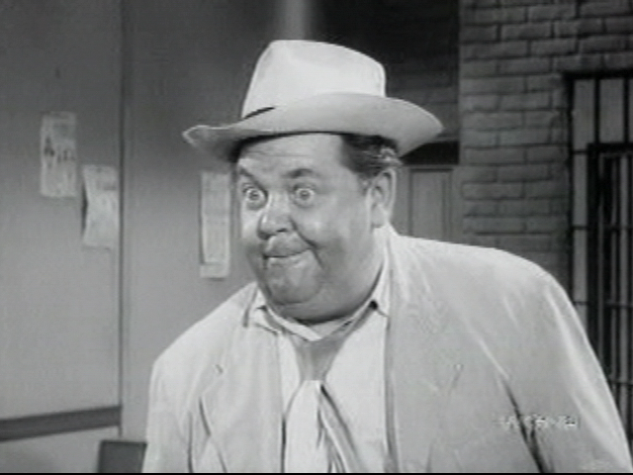
2007 Otis Invitational

Official Otis Rules

Unless otherwise stated by the rules committee (Jason, Bump and Mike), USGA rules apply. Here are some clarifications and local rules that should help eliminate confusion.

SHOW UP!
We go through a lot of planning to set up the Otis each year, so if you cannot make it, please do everything possible to tell us early and we will try to find a replacement. Uneven scramble teams are not fun for anybody. If you play, you will be among the first to get invited back every year!

PLAY WHEN YOU ARE SCHEDULED!

It is difficult to set up the tee times so that people do not play with the same foursome every day, and still
keep teams fairly even. If you cannot play in the first or last tee time Sunday morning, you are not Otis material and you should stay home! Even though your odds are good that you will play when you want, be prepared to stick it out until the last minute. Do not assume you can get home early on Sunday. Make your travel plans accordingly. You have been warned.

NO COMPLAINING about the conditions or rules!

NO GIMMIES!

KEEP PACE:
Please take no more than 10 strokes per hole. If you hit the ball 10 times and are still not in the hole,
give it up and move on!
Please keep up with the group ahead of you. We need to get a lot of people through the course in time
to tee off again in the afternoon, and we do not want dinner to be later than it has to be.

RAIN:
You are expected to play through all weather. We follow a modified Otis rule.(The original Otis rule is, if the bar is open, you must drink!), thus the modified rule is: if the course is open you must play. With this in mind, be prepared with an umbrella, rain suit, multiple towels, and spare gloves. As Bill Murray would say, “I don’t think the hard stuff will come down for a while” Remember, we are coming a long way to play, so be prepared! Besides, everyone will face the same conditions.

SHIRTS & SHOES:
Soft Spike shoes are required. Most of us have converted by now, but it is still worth mentioning. Please wear shirts with a collar.

TEE TIMES
Arrive at least 20 minutes before your morning tee time.

MOVING THE BALL:
Fairway and Rough- You are allowed to move the ball no more than six inches – must stay on same surface.

OUT OF BOUNDS:
All Courses - All holes - you are allowed to drop the ball where it went OB with a ONE stroke penalty.

If the ball is OB but playable, you still must drop it back in play and take the one stroke penalty!

LOST BALLS: (This year’s honoree is Brandan Mueller, who is missing this year’s Otis AGAIN…) You may drop a ball in the area where you think the ball disappeared (you must get agreement from your partners on the spot), and then take a ONE stroke penalty.

WATER HAZARDS:
Standard - Drop where the ball crossed the margin of the hazard, one stroke penalty (i.e., on a par 3
if you hit your tee shot in the water, after your drop, you will be hitting your 3rd shot.)

SCORECARDS:
Must be signed by each member of the group and given to Zim after each round.

SCRAMBLES:
Drives: Minimum of 2 drives must be used from each player
Position - You must hit your shot within 1 club length of where the ball was marked. You can
not change the playing surface (i.e., if you are in the rough or sand you must play the ball from
the rough or sand). Also, you may not move the ball closer to the hole.
Putting: Once the ball is in the hole, that is your score (i.e., DON’T tap the ball in if someone else still
has a chance to make the putt!!)
Finish: Weather permitting, wait at least 30 feet behind the green for the following groups.

Friday Morning Individual Score
(Shotgun start – everyone needs to tee off at 7:15 AM!)
Name | Otis Score
Randy Hill | 79
Mike Reda | 96
Billy Krueger | 82
Mark Lutz | 106
Fred Watson | 79
Bryan Rehfeldt | 96
Jordan Zimberoff | 96
Jason Zimberoff | 92
Demetri Tsiropoulos | 85
John Wucki | 100
Pat DiDomenico | 99
Terry Bulger | 95
Jay Huseth | 85
Rob Rains | 102
Adam Kommers | 85
Travis Schuler | 105
Kai Bobkowski | 90
Nate McGowan | 95
Scott Kossman | 110
Dave Compton | 96
Ron Blink | 79
Tim Monti | 100
Robert Planica | 108
Todd Krumwiede | 100
Daryl Krumwiede | 92
Steve Rehfeldt | 105
Mark Fankhanel | 92
John Hayes | 104
Greg Wilson | 86
Phil Joschko | 98
Lance Murphy | 100
Steve Ryan | 90
Mike Redenbaugh | 87
Chris Schoenfeld | 84
Jeff Lake | 93
Kevin VanAlstyne | 102
Friday Afternoon Scramble
Name Otis Score
Randy Hill | 79 | -1 | 10
Daryl Krumwiede | 92 | 2
Bryan Rehfeldt | 96 | 3
Randy Comstock | 110 | 6
Ron Blink | 79 | -1 | 11
Steve Ryan | 90 | 2
Pat DiDomenico | 99 | 4
Rob Westover | 110 | 6
Fred Watson | 79 | -1 | 11
Nate McGowan | 95 | 3
Todd Krumwiede | 100 | 4
Steve Rehfeldt | 105 | 5
Adam Kommers | 85 | 0 | 11
Jeff Lake | 93 | 2
John Wucki | 100 | 4
Mark Lutz | 106 | 5
Bill Krueger | 82 | 0 | 13
Terry Bulger | 95 | 3
Phil Joschko | 98 | 4
Ken Redenbaugh | 108 | 6
Mike Redenbaugh | 87 | 0 | 13
Jason Zimberoff | 92 | 2
Travis Schuler | 105 | 5
Scott Kossman | 110 | 6
Chris Schoenfeld | 84 | 0 | 12
Mark Fankhanel | 92 | 2
Bump Waghorne | 98 | 4
Robert Planica | 108 | 6
Jay Huseth | 85 | 0 | 11
Dave Compton | 96 | 3
Mike Reda | 96 | 3
John Hayes | 104 | 5
Greg Wilson | 86 | 0 | 13
Jordan Zimberoff | 96 | 3
Kevin VanAlstyne | 102 | 5
Rob Rains | 102 | 5
Demetri Tsiropoulos | 85 | 0 | 10
Kai Bobkowski | 90 | 2
Tim Monti | 100 | 4
Lance Murphy | 100 | 4

Saturday Morning Individual Score
(Shotgun Start – Everyone needs to tee Off At 7:20 !)
Name | Otis Score
Fred Watson | 79
Randy Hill | 79
Bill Krueger | 82
Adam Kommers | 85
Ron Blink | 79
Demetri Tsiropoulos | 85
Greg Wilson | 85
Mike Redenbaugh | 87
Chris Schoenfeld | 84
Jay Huseth | 85
Kai Bobkowski | 90
Steve Ryan | 90
Jason Zimberoff | 92
Terry Bulger | 95
Rob Rains | 102
Travis Schuler | 105
Daryl Krumwiede | 92
Phil Joschko | 98
John Wucki | 100
Kevin VanAlstyne | 102
Mark Fankhanel | 92
Lance Murphy | 100
Robert Planica | 108
Scott Kossman | 110
Jeff Lake | 93
Jordan Zimberoff | 96
Todd Krumwiede | 100
Mark Lutz | 106
Bryan Rehfeldt | 96
Mike Reda | 96
Tim Monti | 100
John Hayes | 104
Nate McGowan | 95
Dave Compton | 96
Pat DiDomenico | 99
Steve Rehfeldt | 105

Saturday Afternoon Scramble
Name HCP Team HCP
Fred Watson | -1
Mike Reda | 3
Lance Murphy | 4
Randy Comstock | 6 | 12
Randy Hill | -1
Terry Bulger | 3
Kevin VanAlstyne | 5
John Hayes | 5 | 12
Ron Blink | -1
Dave Compton | 3
Tim Monti | 4
Rob Rains | 5 | 11
Bill Krueger | 0
Kai Bobkowski | 2
John Wucki | 4
Scott Kossman | 6 | 12
Chris Schoenfeld | 0
Bryan Rehfeldt | 3
Jordan Zimberoff | 3
Steve Rehfeldt | 5 | 11
Adam Kommers | 0
Jason Zimberoff | 2
Pat DiDomenico | 4
Robert Planica | 6 | 12
Demetri Tsiropoulos | 0
Steve Ryan | 2
Mark Fankhanel | 2
Ken Redenbaugh | 6 | 10
Jay Huseth | 0
Daryl Krumwiede | 2
Todd Krumwiede | 4
Mark Lutz | 5 | 11
Greg Wilson | 0
Jeff Lake | 2
Nate McGowan | 3
Travis Schuler | 5 | 10
Mike Redenbaugh | 0
Bump Waghorne | 4
Phil Joschko | 4
Rob Westover | 6 | 14

Sunday Morning Scramble
(Shotgun start – everyone needs to tee off at 7:20!)
(Teams To Be Announced)

Name

Player Bios

This is the famous Otis Bio section. If you have a better nickname, tell

Bump, Rob, Mike, or Zim and we will change it next time...

Score Name Otis Nickname Information

79 Randy Hill "The Under-stater" “I am not playing that well” may be heard frequently as he makes boring two putt
pars. But we all know better now. The only thing that surprised us was that he
actually got beat for low gross by Billy Baroo the last time he played. Will he be able
to regain his scoring crown after missing the last Otis? Probably.

79 Fred Watson (New Guy) This year’s new mystery – we have decided to throw him up here at the top of the list
after receiving a copy of his handicap in our email. Fred comes to us via John Wucki
as one of his regular playing partners. One thing we know – if he is really as good as
his 6 handicap, he is going to be in the running for some Otis money. Welcome to
the Otis, and good luck!

79 Ron Blink “Fade” Ron played great again last year, earning him the top spot in the low gross rankings
all by himself for 2006. But we must be wary of his nickname. As the weekend grows
old, will his Otis Poster Boy tendencies cause his skills to “fade” with each Falstaff?
Stay tuned…

82 Bill Krueger “Billy Baroo” Billy continued his great play at the Otis last year, losing out on the low gross tile by
only 1 stroke. Always positive – even when things are not going well – Billy is the
ultimate upbeat scramble partner. If you are playing with him this year, bring your
beer, and your earplugs.

84 Chris Schoenfeld “Tophs” After missing the last two Otis competitions, Chris is finally back to reclaim his long
lost glory. Since winning the low gross title in Otis #1, he has failed to do it again
since. The competition has gotten older, but we have also added a few ringers too.
Will he come roaring back to the top? Or is he “just here for the beer”? Welcome
back!

85 Adam Kommers “Rowdy Roddy Piper” Adam is flying in to Rhinelander to participate in this year’s Otis. Now his mad dash
to the airport after Sunday’s round will involve crossing the street and waiting for them
to begin boarding. Voted most likely to drink a half yard and also most likely to find
the elusive Northwoods Hooters.

85 Demetri Tsiropoulos “The Pro” Direct from Calgary, this former Greek professional soccer player is now a member of
an even more elite group – the Otis golf brotherhood. The soccer career ended with a
blown out knee, but the golf game is still rumored to be good, and Demetri’s all around
athletic ability will no doubt be a great asset to any scramble team. Can he “bring it”
in Wisconsin? Welcome and good luck!

85 Jay Huseth “JayBird” Jay finished a respectable 5th in last years low gross rankings. He returns this year to
see if he can crack the top 5 in an improved field. Jay was kind of quiet last year in
his first Otis. Lets see if the “taste of the Northwoods” brings him out of his shell a
little this year.

86 Greg Wilson “Wanna Bet?” After missing last year, Greg is returning to his first Otis since hitting the big 5-0.
Don’t forget that he will bet on anything. So let’s start: We bet he will consume his
fair share of Fallstaffs. We bet he will be in the running to win all of the scrambles.
And we bet that he will need some sunscreen on his head before the weekend is over.
Welcome back!

87 Mike Redenbaugh “Baugh” Mike started to find his old form (his old golf form that is…) last year as he hit the
trifecta over the weekend… He won a closest to the pin, a long drive, and even a long
putt last year. Mike also has the ability to win low gross if everything is working right,
but that has not been the case recently. We are playing in Mike’s future backyard this
year, as he is getting ready to move to Minocqua permanently. Will his new home
courses treat him well? Only one way to find out!

90 Kai Bobkowski “Kai Bob” Kai was extremely rusty last year, and if it were not for past success, we would
probably be moving him down this list. But we are guessing that it was just a small
detour for him, and that he will be back this year with a vengeance. This year the
pressure is off - as he is now the highest ranked “B” player. But if not – there is
always the booby prize for “high net”…

90 Steve Ryan “The Putt” Steve held his own last year as an “A” player, and even though his Otis score has not
changed, the addition of a few new ringers ahead of him this year should help take some of the pressure off in the scrambles. Look out.

92 Daryl Krumwiede “Brother Daryl” Daryl is now joining an elite group – Otis players who have played with their own sons
in the invitational. Daryl says that he needs to give his son 5 strokes. We are giving
Todd 8. But we know Daryl is up to it. One of the most improved golfers in the group
since the beginning, Daryl finished in the top 10 again last year for low gross. Lets
see if he can continue to represent the “Ryan Ringers” with success…

92 Jason Zimberoff “Zim” Zim is now a dad. Nolan was born March 18, 2007 – so needless to say there has not
been a lot of golf for him lately. But that’s ok. It seems like the less he plays, the
better he gets. Seems like low expectations are the key to keeping his mind calm.
He subscribes to the Zen golf philosophy: “If things are not going well, take two
weeks off and then quit.” But just to be safe, hide your favorite driver if you are
sharing your cart with him…

92 Mark Fankhanel "Mr. Sunscreen" Mark has all of the potential to be one of the better golfers in the Otis. But he also
rooms with and often plays with the original Otis poster boy – his brother in law Lance
Murphy. With that in mind, we expect him to mow through the competition. Especially if the competition is a 6 pack of Miller Lite.

93 Jeff Lake “Mr. Demo Day” Jeff never met a golf club salesman he could refuse. He is also well known for being
most likely to miss his Otis score by the largest margin. The only problem is we never
know which way he is going to miss it. When he is on – he is on. When he is off –
time for a new set of clubs!

95 Nate McGowan (New Guy) Daryl Krumwiede’s Son In Law is joining us for his first Otis. No doubt Daryl has told
Nate about the athletic build of most Otis players and told stories about the amazing
endurance that most of us show each year. Or – maybe Nate has already planned
head and had his padded table shipped to Minocqua ahead of time. Keep his beer
from running out, and maybe you’ll get a free adjustment too! Welcome and good
luck!

95 Terry Bulger “The Banker” Another one of the original Lapski golfers – Terry was the one who originally invited
the Redenbaugh’s to the Lapski. So basically – this is all his fault. Terry’s job often
keeps him from playing in the Otis, so we are happy to have him back again for the
10th invitational. He hits the ball from the wrong side, but that is probably because he
was originally from Canada. Welcome back and good luck!

96 Bryan Rehfeldt “The Professor” Bryan missed last year’s Otis – and it has bothered him the whole time since. So
when his daughter was getting ready to set the date for her wedding this year, he began to come up with good excuses for missing it just in case she picked the same
weekend as the Otis. Luckily, she was married on Memorial Day weekend, so all is
well. Welcome back!

96 Dave Compton “The Land Barron” Dave’s Otis score is creeping back up after last year’s display. But we know him too
well to give him too many strokes. He has been known to play great and awful in very
short succession – so expect anything. Also – the close proximity to so many fishing
spots is sure to distract Dave. If you see that 14th club in his bag, it is probably just a
fishing pole.

96 Jordan Zimberoff “Little Zim” Jordan just completed his first year of teaching full time and is well on his way to a
great career in the educational field. Now if he would only take some of his own (and
everyone else’s) advice and slow down his swing he might get his score down and out
of the middle of the pack. With a career of summers off ahead of him, look for a
drastic improvement – unless his stubbornness keeps him swingin’ out of his shoes.

96 Mike Reda “Choke” Some people say that hockey players often have a naturally good golf swing. Mike is
a hockey player – so that rule must be false. He has shown moments of brilliance in
the past, but was pretty mediocre last year. But this is part of the fun of the Otis.
Which Choke will show up this year?

96 Pat Mackey "Late Night" Pat was last year’s Otis Poster Boy after helping pilot a golf cart through a perfectly
manicured sand trap. Pat and Adam were perfect for each other that day, each
elevating their game to new Otis heights. This honorary bio is included to let Pat
know that we will miss him this year, and that we hope he gets well soon!

98 Bump Waghorne “Sweet Swingin’” Bump, Sweet Swingin’ Willie T. Wags & Mr. Sunday, all are actually the same person
and he will need to get his back stretched out to see if he can get into the money this
year. If his early play on the softball diamond is an indication of his recovery, look out.
if he does stiffen up again, at least he can comfort himself with the knowledge that the
musky are bitin’ and Wisconsin has very liberal drinking laws.
98 Phil Joschko “Mr. Mermaid” So, what is Phil going to do this year? Do we need to change his nickname? We all
know that Phil can motor out of a parking lot faster than a speeding bullet, but the 9
hour drive to Mermaids may be too much even for him. Will Phil find a local
establishment to drown his sorrows? The good money is betting “yes”.

99 Pat DiDomenico “Dee-Doe” Another year, another prediction of Otis success. Pat claims to be playing better
lately, and looks to win some low net money this year. Why is his score still at 99?
Well, this is pretty much the same thing we said last year, and the year before, and
the year before that. At least this year Pat can drown his sorrows at the ol’ fishin’
hole…

99 Tim Monti “Coach” Coach is always smiling. We are not really sure why. He must be up to something.
Keep your eyes peeled, maybe you can figure it out. At least we know it is not his
short game. While Tim can boom his drives with the best of us, his game has more
holes than the Cub’s infield - keeping him mired in the middle of the Otis pack. Will
Coach break out this year or will his smile only hide his pain?

99 John Wucki “Chewy” John and Jeff Lake are connected by family ties and more as they share two lovely
granddaughters, both live in Glen Ellyn, and both are scary good at times on the golf course. Can John overtake Jeff this year as the best golfer in the family, time will tell. At least his jokes are better than Jeff’s…

100 Todd Krumwiede (New Guy) Todd has the honor of being the first “second generation” Otis participant. (Yes, we
have multiple generations already present, but Todd was 13 when we started this nonsense, a mere pup). It will be interesting to see if he can keep up with his dad on the golf course and at the bar! Are the Ryan’s bringing a true ringer? We will see. Welcome to the Otis!

100 Lance Murphy “Murph” Last year Lance delayed a family vacation to Disney World to attend the Otis. We’re
not sure what his penance was, but we hope he returns with all of his “golf” balls this
year. It should also be noted that Lance’s prowess on the golf course is legendary,
now whether that is in the area of shot making, putting, chipping, or drinking is strictly
confidential.

102 Kevin VanAlstyne “Iron Gut” Kevin has the unwelcome honor of being the Otis golfer most likely to ride the
porcelain bus to the golf course. Unlike his fellow Otis over-indulgers, Kevin can at
least claim his illness was due to bad food…Kevin moved from Calgary to Naperville
on the whims of his employer, so N. Wisconsin will still be way down south yonder for
Kevin – we expect to see Bermuda shorts and panama hats on the first tee (although
he’ll take a pass on the sushi).

102 Rob Rains “Big Rob II” For those of you that have been reading the Otis emails this past spring, you know
that Rob and Adam K. are cousins and often room together. You also know that Rob
and Adam have a unique sleeping arrangement worked out for this 10th anniversary
year. How did that song go? “Sleeping double in a single bed…” Or something…
Wish them luck. At least Rob can be remembered as the lowest scorer on “Team
Buffet “ at the golf course.

104 John Hayes “The Anchor Man” Those of us that have had the pleasure of golfing or bowling with John know that he is
always a joy to hang out with. But seeing him bowl and golf, you might wonder why.
As John’s bowling average and golf handicap continue to find common ground, we
know that, regardless of the outcome, John and the rest of his group will come out
smiling.

105 Steve Rehfeldt “Radar” There are rumors that Steve has been bitten buy the “it must be the clubs” bug - he
bought a new driver. There are further rumors that this driver is actually working and
he is booming his drives upwards of 275 yards. There are yet even more rumors that
the internet company he bought the club from has since gone out of business or is
under FBI investigation for trade and copyright law infringements. Whatever the “real”
story is, look for Steve to shed his nickname and hit is big this year.

105 Travis Schuler “Hair Gel” Another new Otis contestant this year, Travis is an NIU grad. So he knows what its
like to be an underdog and upset the big boys so look out if you are at the top of the
list. As the owner of a 66 Mustang, he also knows what its like to have the girls
whistling at him from the sidewalk (too bad all the girls are in their 60’s!) Travis will try
to emulate his favorite Badgers and win in Wisconsin! Good luck and Welcome to the
Otis.

106 Mark Lutz "Buckeye" Last year we made fun of Mark’s alma mater (The Ohio State) in his bio. Um, well, I
guess unless any of us went to the University of Florida we should lay off of his this
year. Second best is still better than…oh never mind. Mark’s golf game gets a chance
to escape from the hated state of Michigan this year, so look out!

108 Ken Redenbaugh “Pa Baugh” Without Ken, there would probably be no Otis. He was one of the original guys to
come up to Kalamazoo with his old neighbor to play in the “Lapski” tournament. Many
divots, injuries, subtle jokes, and lost balls later, Ken is still at it and wouldn’t have it
any other way. It wasn’t the same without him last year, and its great to have him
back.

108 Robert Planica “Little Rob” Rob is new to the Otis this year and one of Bump’s invitees. We won’t hold that
against him. Not sure how his golf game is going to work out up north, but if it is
anything like his softball game it will always be at top speed and quite exciting, if not
completely under control. Welcome to the Otis and good luck!

110 Randy Comstock "Burgertime" Randy has some memorable moments on the golf course. Unfortunately, none of
them have anything to do with golf. With the rumors floating around that there may be
some good fishing in the area, Randy may finally reel in the big one at this year’s Otis.
Whether it’s birdies or bass that he’s hunting for, Randy is always a living up to the #1
Otis rule.

110 Rob Westover “Big Rob” Rob is now the honorary “Captain” of team buffet and should continue to lead the
boys in their wanton debauchery. Regardless, Rob is always one of the best scramble
partners with his penchant for hitting humongous drives that travel at least 300 yards
(150 out, 150 straight right). And when Rob is on your team, everyone will have a little
Captain in them.

110 Scott Kossman “Scotty WOO” Koss is sure to bring back his always top notch Otis wardrobe for another year of GQ
quality first tee appearances. We always wonder where Scott gets his inspiration for
his wardrobe choices each year, and judging by his scores, is not the most recent golf
catalog. Go Illini!

Otis Invitational History

Long ago there was a group of guys who played golf on Sunday Mornings at Arrowhead golf course in Wheaton. One of them was Terry Bulger, who worked for a bank in Chicago. One day (sometime in the late ‘80’s ) Terry asked two of his golfing partners - Ken Redenbaugh and his son Mike – if they would like to join him in a golf outing run by some of the guys he worked with at the bank.

These two co-workers had organized a golf outing in Kalamazoo Michigan at Thornapple Creek golf course, and played 90 holes there in three days. The group made up of mostly bank employees and their friends was called the Lapski – after its co-organizers named Gonski and Lapitina.

Back then, Thornapple was a course unlike any that they had seen. Rolling terrain, a great layout with lots of trouble, and unbelievably fast greens. It was truly a golf paradise.

Terry, Mike and Ken played in the Lapski for a number of years – occasionally adding a few other neighbors and friends to the group. Eventually, Mike asked his friend Jason Zimberoff to join the group.

By this time, the Lapski group had grown to about 40 men, but the quality of the greens at Thornapple started to fall off from the glory days. So, they had also added another course to the schedule on Saturdays, called Heritage Glen. The Friday and Sunday rounds were still played at Thornapple though.

The Lapski golfers were also more serious about the winning and scoring, and it sometimes led to a lot of under-the-breath muttering about sandbaggers and people not following the rules. It did sometimes take away from what we thought the spirit of the trip should be.

With the addition of Jason Zimberoff also came many of his friends and family members. After a couple of
years, Mike and Jason were bringing at least 12 guys to Michigan with them to play in the Lapski – and a great time was had by all…

Until one dark day at the beginning of 1998, Mike got the phone call that changed history forever. The Lapski group wanted to go back to inviting more of the bank employees and more of their friends, and we were asked to only bring 4 players that coming summer.

That was all we needed to hear. How could we choose who could and couldn’t go? Would we hang our heads and agree to this? NO!

The group of Mike Redenbaugh, Jason Zimberoff, Bump Waghorne, and Rob Westover, all former Lapski players, decided to create a new outing based on the self-described “Oti” (pronounced oat-eye) club of over-served
drinking buddies… named, of course, after everyone’s favorite town drunk – Otis Campbell of Mayberry.

We immediately got together and came up with the idea for the Otis Invitational. A group that would be made up of all of our friends and family. Although we did bring many of the long-time Lapski guys with us, we hope that we left all of the bickering and BS with the old group. We even replaced the Sunday individual scoring round with a scramble to make it more fun – along with a few other minor changes that we all wanted to make.

This year, we again return with 40 of our own players, and three golf courses! We wouldn’t have it any other way. Thanks to everybody who has participated these nine years, and here’s to 50 more!

Directions to the AmericInn from Chicago

From the South – take I-88 West to I-39 North.
From the North – take I-90 west to I-39 North in Rockford.
For everyone:
Follow I-39 / I-90 North through Rockford.
I-39 will split off from I-90 in Portage, WI. Stay on I-39 North.
I-39 will become US highway 51 in Wausau, WI. Stay on US 51 North.
US 51 will bring you all the way to Minocqua, and the hotel is on US 51.

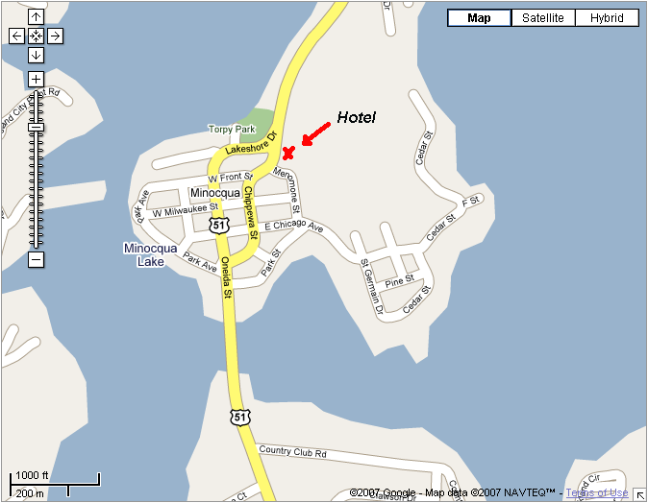

AmericInn of Minocqua
700 Highway 51 North.
Minocqua, WI 54548
Tel: 715-356-3730
Fax: 715-356-6958
Check-In Time: 3:00 PM
Check-Out Time: 11:00 AM

www.americinn.com
T. Murtaughs (Thursday Night)
This establishment is on South US Highway 51 right in the middle of downtown Minocqua.
The street is one way to the south only in front of the bar.
Please park at the hotel and walk!

500 Oneida Street
Minocqua, WI 54548
(715) 356-1366

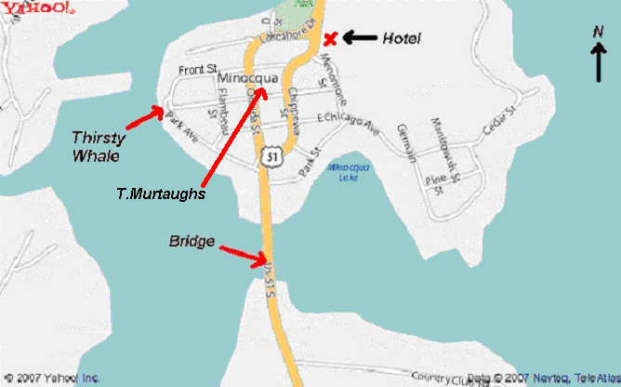

The Thirsty Whale (Saturday Dinner)
This restaurant is also right on the lake, on the west side of the island.
From the Hotel - go back south on US 51
turn right on Front Street follow to the end, and turn left on Park.
Restaurant is in parking lot for boat landing – on the lake on your right.

Park Ave. and Milwaukee St (on the lake)
Minocqua, WI 54548
(715) 356-7108

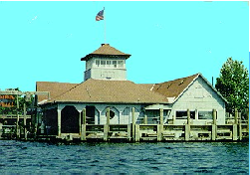

Directions to Timber Ridge Golf Club from AmericInn

Take US 51 4 miles south of Minocqua.
Turn right on Ridgewood Drive.
Continue straight on Timber Ridge Drive
or follow signs to golf course.

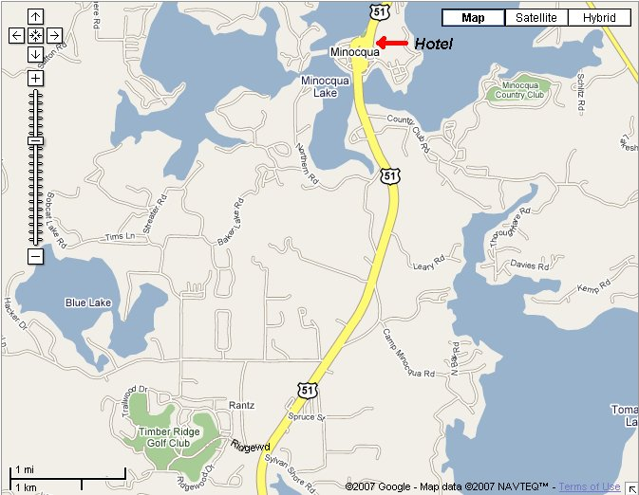

Timber Ridge Golf Club

10030 Timber Ridge Road

Minocqua, WI 54548
(715) 356-9502
Directions to Trout Lake from AmericInn

Follow US 51 for 10 Miles North of Minocqua.
Look for Trout Lake signs on the left side of the Highway.
Turn into drive and follow back 1 mile to clubhouse.

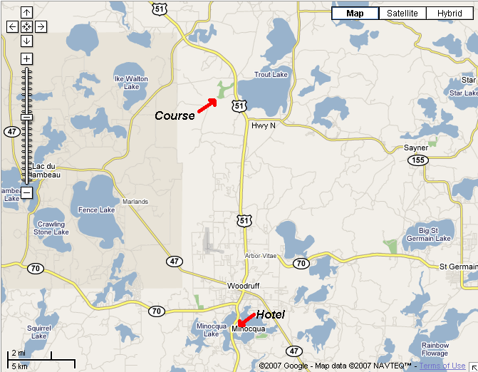

Trout Lake Golf Club
3800 Highway 51 North
Arbor Vitae, WI 54568
(715) 385-2189

Directions to Northwood Golf Club From AmericInn

Follow US 51 north for 2 Miles to Wisconsin Highway 47 south.
Follow Wisconsin Highway 47 south for 24 Miles to US Highway 8 West.
Follow US Highway 8 West for 2.6 Miles to Golf Course Road.
Turn left (south) on Golf Course Road and follow to course.

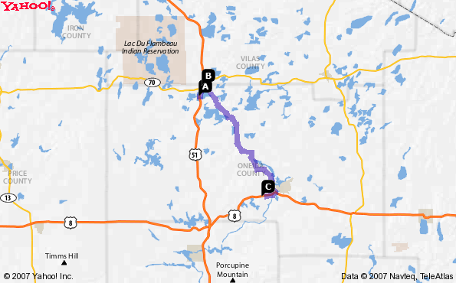

Northwood Golf Club
6301 US Highway 8 West
(3131 Golf Course Road)
Rhinelander, WI 54501
(715) 282-6565



Timber Ridge Golf Club

10030 Timber Ridge Road

Minocqua, WI 54548
(715) 356-9502
(Friday)

Timber Ridge Golf Club has been known as one of the top golfing experiences in Northern Wisconsin.
This Par 72, Championship layout is an exciting challenge for all levels of play. With 5 separate tee boxes per hole, it is guaranteed to thrill both casual and skilled golfers alike. You will enjoy a picturesque view on every hole, while challenging your game on our perfectly carved fairways and undulating greens.
Timber Ridge lies amongst the beauty of the northwoods, but also has the class of private community. Timber Ridge Golf Club has plenty amenities for you. Such as a fully stocked pro shop, an attached Bar & Restaurant, a full driving range with putting and chipping area, handheld GPS laser links and many more amenities that will make you come back, again and again.
Between our friendly staff and beautiful scenery, Timber Ridge guarantees the ultimate golf experience.

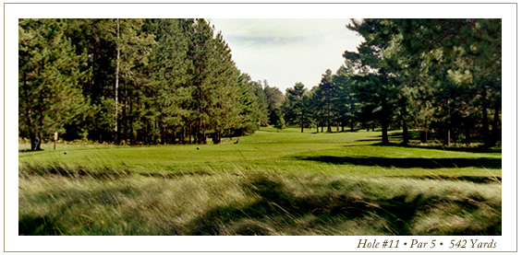

Blue Tees: Course Rating 72.0, Slope 129, 6686 yards
White Tees: Course Rating 70.3, Slope 125, 6308 yards


Trout Lake Golf Club
3800 Hwy 51 North
Arbor Vitae, WI 54568
715-385-2189
(Saturday)

Established in 1924, Trout Lake Golf Club, is the oldest 18-hole golf facility in the Northwoods. After the completion of the back nine in 1926, Trout Lake Golf Club has become a premier golfing destination in the Northwoods and has been enjoyed by the thousands. The clubhouse is the original 1880's logging home, and was recently remodeled with extensive work on the fireplace, golf shop and the historic screened porch overlooking the 18th fairway. You must come out to relax by the fire or the porch and enjoy some beverages.
Our newest "Claim to Fame" is the Practice Facility featuring 325 yards of range, a 7000 square foot putting/chipping green, a 3500 square foot bunker/chipping green and an exceptional pavilion to relax under and watch others bang 'em out there! This Practice Facility is the best in the Northwoods, hands down.

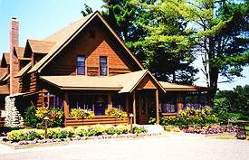
Our clubhouse...an 1800's logging home!

White Tees: Course Rating 69.9, Slope 124, 6175 yards



Northwood Golf Club
3131 Golf Course Road
Rhinelander, WI 54501
(715) 282-6565
(Sunday)

Northwood Golf Club is carved out of ancient rocks, rolling hills and dense forests. Northwood opened for play in May 1989. Designed by Minneapolis golf course architect, Don Herfort, Northwood lies on a 2600-acre parcel of land that nature did a great job of landscaping before he arrived. To his credit he used the natural feeling of nature to create a golf masterpiece.
Northwood is located just minutes away from 232 freshwater lakes, the Pelican and Wisconsin Rivers, modern accommodations and fine dining. Experience the thrill of playing a course that the WSGA rated 5th in Wisconsin from 1989-1994.

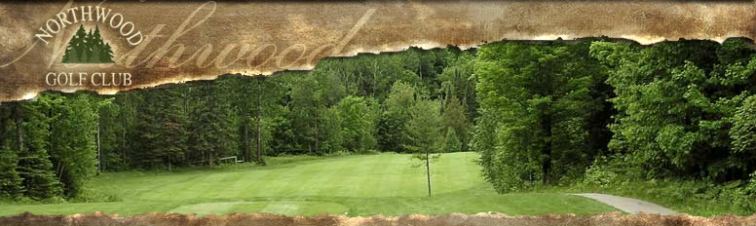

Gold Tees: Course Rating 73.1, Slope 140, 6724 yards
Blue Tees: Course Rating 71.5, Slope 136, 6356 yards
White Tees: Course Rating 69.7, Slope 124, 5863 yards

