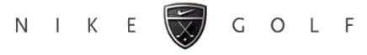

The 7th Annual
Otis Invitational
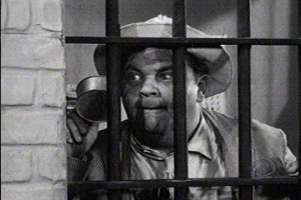

June 11, 12, 13 - 2004

Hosted By
Thornapple Creek Golf Club
Heritage Glen Golf Club
Lynx Golf Course

www.svs.com/zim/otis
 $5.99 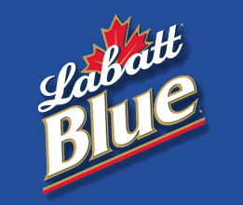
7th Annual Otis Invitational

Welcome Otis Participants!

This program will become your Otis bible, containing and pertaining to everything you could want to know about the tournament.

The most important rule, as always is to have a great time.

And in addition to the rules, this program contains prize money info, format, tee times, logistics, and of course, the now infamous Player Bios.

The logistics section includes directions, multiple maps, and for those of you who enjoy taking the back-roads, phone numbers for when you get lost.

Our final count for 2004 is at 44 players.

If you cannot play, let us know immediately, so we can fill your spot. Uneven scramble teams are no fun for anybody. Also, we have already committed to bring 44 people, and deposits have been paid. If we can’t replace you, you may not get a refund.

Make sure you reserve your room at the Hampton Inn. Call them at 269-372-1010. Rooms are approx. $89 per night double occupancy. Each room will have 2 double beds. To Reserve your room, call immediately for the Otis Golf Outing.

Tee times begin at 8:00 AM on Friday, 8:00 AM on Saturday and 7:48 on Sunday. Please make sure you get to the course ahead of time. Please show up for the first tee time even if you are not teeing off first.

Soft spikes are required, so bring a replacement set of spikes if you still use the metal ones.

Tee Markers: We will play the white tees for the individual rounds, the blue tees for the scrambles on Friday and Saturday, and the white tees for the scramble on Sunday.

We will have a group dinner on Saturday at the Hampton Inn in Kalamazoo. We hope everyone will participate. The dinner price is included in your entrance fee, and includes appetizers, dinner buffet, beer, wine, and tip. Since we have a large group, there will be a buffet with steak and chicken.

We will also be meeting in the bar at Gallagher’s (formerly Chianti’s) on Thursday (after 9:00 p.m.) if you are interested in meeting up with many of the participants before the tournament.

The Prizes will be distributed as follows:

Closest To The Pin (4 holes per round, all 5 rounds) $30
Long Drive (1 hole per round, all 5 rounds) $30

Long Putt (2 holes per morning round) $30

Long Putt (2 holes per afternoon round) $30

Low Net 1st place (one person, each stroke play round) $50
Low Net 2nd place (one person, each stroke play round) $45
Low Net 3rd place (one person, each stroke play round) $40
Low Net 4th place (one person, each stroke play round) $35
Low Net 5th place (one person, each stroke play round) $25
Low Net 6th place (one person, each stroke play round) $20
Low Net 7th place (one person, each stroke play round) $15
Low Net 8th place (one person, each stroke play round) $10

Scramble Team Winners (each person, each scramble round) $50
Scramble Team 2nd place (each person, each scramble round) $40
Scramble Team 3rd place (each person, each scramble round) $30
Scramble Team 4th place (each person, each scramble round) $20
Scramble Team 5th place (each person, each scramble round) $15
Scramble Team 6th place (each person, each scramble round) $10

The golf fees for all 5 rounds will be $181 per person (includes green fees and riding cart)
Betting / prize / Saturday dinner money is $119 for the entire weekend.

Total cost per person: $300 (not including the hotel room.)

Birdie pool is optional. If you get in, you will pay $1 for every birdie made by others, and receive $1 from everyone else if you make a birdie. If someone scores an eagle, it will be counted as 2 birdies. A double eagle will count as 3 birdies. (Ya never know....)

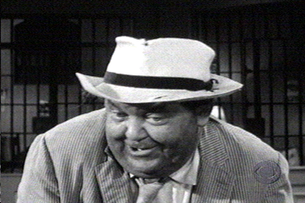

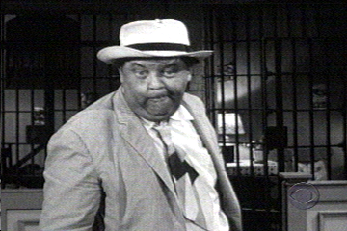

2004 Otis Invitational
Official Otis Format

Friday AM - Stroke play with your foursome at The Lynx. Prizes are awarded for the 4 closest to the pin markers, long drive in the fairway on #18, longest putt made on #9 & #18, and to the top 8 finishers.

Friday PM – 4 man scramble play at The Lynx. Teams are determined by a high/low pairing based on your pre-tournament approved score. For example, each team would consist of players ranked in the A, B, C, and D tiers (to be determined ahead of time.) Prizes are awarded for the 4 closest to the pin markers, long drive in the fairway on #18, longest putt made on #9 & #18, and to the top 6 teams.

Saturday AM - Stroke play with your foursome at Thornapple. Prizes are awarded for the 4 closest to the pin markers, long drive in the fairway on #9, longest putt made on #9 & #18, and to the top 8 stroke play finishers.

Saturday PM - Handicapped 4 man scramble play at Thornapple. Teams are determined by a blind draw with two players from the “A” pool (players 1-20) and two from the “B” pool (players 21-40). Handicaps are computed based your pre approved average score. The scale is as follows: an Average score less than 86 is a 0, 86-90 is a 1, 91-95 is a 2, 96-100 is a 3, 101-105 is a 4, 106-110 is a 5, and 112 or greater is a 6. If your team has players who average 85, 93, 96, and 112, you would receive a handicap of 11. Prizes are awarded for the 4 closest to the pin markers, long drive in the fairway on #18, longest putt made on 9 & 18, and to the top 6 teams.

Sunday AM - 4 man scramble play at Heritage. For this round, we have tried to draft even teams. Prizes are awarded for the 4 closest to the pin markers, long drive on #18, longest putt made on #9 & #18, and to the top 6 teams.
Official Otis Logistics

Tournament Date: Weekend of Friday, June 11, 2004

Tournament Location: The Lynx Golf Course
Otsego, Michigan (269) 694-5969

Thornapple Creek Country Club
Kalamazoo, Michigan (269) 344-0040

Heritage Glen Golf Club
Paw Paw, Michigan (269) 657-2552

Motel Accommodations: Hampton Inn & Suites
(5059 S. 9th St. Exit 72 North, 269-372-1010)
Rooms are $89 per night double occupancy.
Each room will have 2 double beds.
Block of rooms reserved under the Otis Golf Outing

Saturday Night Dinner: We will have the entire group eat together at our hotel in Kalamazoo on Saturday night. Your dinner is included in the entry fee. Steak & Chicken buffet will be provided with beer and wine included. For other meals, you are on your own. There are many good spots to eat around the hotel.

Tournament Format: 36 Holes on Friday and Saturday, 18 Holes on Sunday

Cost Breakdown: Greens Fees are $181 for the entire weekend. This includes 90 holes of golf,
($300 Total per person) and a riding cart. Betting, Prize and Dinner money is $119 for the entire weekend. (for closest to the pin, low net, long drive, long putt, scramble winners, the dinner, and other goodies.)
Birdie pool is optional. If you get in, you will pay $1 for every birdie made by others, and receive $1 from everyone else for each birdie you make. Please send all checks to Rob Westover, 765 Dogwood Lane, Lake In The Hills, IL 60156.

Tee Times: Begin at 8:00 on Friday, 8:00 on Saturday, and 7:48 am on Sunday.

Player Handicaps: Your handicap will be determined by a mutually agreed upon average score.
If you have not played with us before, you will need to agree on a score with
someone who has. We will adjust your score up or down if we determine that
you normally play a very easy or difficult course. We ask you to be honest. The
competition will not be very much fun if there are a lot of “sandbaggers”.

Other information call Jason Zimberoff at 630-876-0023
Bump Waghorne at 630-736-8170
Rob Westover at 847-854-6625
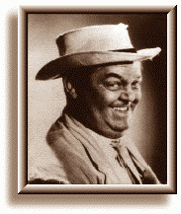
2004 Otis Invitational

Official Otis Rules

Unless otherwise stated by the rules committee (Jason, Bump and Mike), USGA rules apply. Here are some clarifications and local rules that should help eliminate confusion.

SHOW UP!
We go through a lot of planning to set up the Otis each year, so if you cannot make it, please do everything possible to tell us early and we will try to find a replacement. Uneven scramble teams are not fun for anybody. If you play, you will be among the first to get invited back every year!

PLAY WHEN YOU ARE SCHEDULED!

It is difficult to set up the tee times so that people do not play with the same foursome every day, and still
keep teams fairly even. If you cannot play in the first or last tee time Sunday morning, you are not Otis material and you should stay home! Even though your odds are good that you will play when you want, be prepared to stick it out until the last minute. Do not assume you can get home early on Sunday. Make your travel plans accordingly. You have been warned.

NO COMPLAINING about the conditions or rules!

NO GIMMIES!

KEEP PACE:
Please take no more than 10 strokes per hole. If you hit the ball 10 times and are still not in the hole,
give it up and move on!
Please keep up with the group ahead of you. We need to get a lot of people through the course in time
to tee off again in the afternoon, and we do not want dinner to be later than it has to be.

RAIN:
You are expected to play through all weather. We follow a modified Otis rule.(The original Otis rule is, if the bar is open, you must drink!), thus the modified rule is, if the course is open you must play. With this in mind, be prepared with an umbrella, rain suit, multiple towels, and spare gloves. As Bill Murray would say, “I don’t think the hard stuff will come down for a while” Remember, we are coming a long way to play, so be prepared! Besides, everyone will face the same conditions.

SHIRTS & SHOES:
Soft Spike shoes are required. Most of us have converted by now, but it is still worth mentioning. Please wear shirts with a collar.

TEE TIMES
Arrive at least 20 minutes before your morning tee time.

MOVING THE BALL:
Fairway and Rough- You are allowed to move the ball no more than six inches

OUT OF BOUNDS:
All Courses - All holes - you are allowed to drop the ball where it went OB with a ONE stroke penalty.

If the ball is OB but playable, you still must drop it back in play and take the one stroke penalty!

LOST BALLS: (This year’s honoree is Jason Zimberoff, who was married on May 22, 2004…) You may drop a ball in the area where you think the ball disappeared (you must get agreement from your partners on the spot), and then take a ONE stroke penalty.

WATER HAZARDS:
Standard - Drop where the ball crossed the margin of the hazard, one stroke penalty (i.e., on a par 3
if you hit your tee shot in the water, after your drop, you will be hitting your 3rd shot.)
Exceptions - #4 at Thornapple: Off the tee, drop on the other side of the marsh by the cart path
#5 at Thornapple: Off the tee, drop on the other side of the lake directly in front of the tee
#17 at Thornapple: Off the tee, drop in the official drop area (if marked), otherwise,
drop just short and to the right of the green.
#11 at Heritage Off the tee, drop on the other side of the marsh.
#16 at Heritage Off the tee, drop on the other side of the lake.

TEE MARKERS: (Important !)
Blue tees on all 18 holes for scrambles on Friday and Saturday, White tees on all 18 holes for individual rounds, and for the scramble on Sunday.

SCORECARDS:
Must be signed by each member of the group and given to Zim after each round.

SCRAMBLES:
Drives: Minimum of 2 drives must be used from each player
Position - You must hit your shot within 1 club length of where the ball was marked. You can
not change the playing surface (i.e., if you are in the rough or sand you must play the ball from
the rough or sand). Also, you may not move the ball closer to the hole.
Putting: Once the ball is in the hole, that is your score (i.e., DON’T tap the ball in if someone else still
has a chance to make the putt!!)
Finish: Weather permitting, wait at least 30 feet behind the green for the following groups.
Friday AM Tee Times
Tee Time Name Score
 | Jack Westover | 93
8:00 AM | Steve Rehfeldt | 103
 | Bryan Rehfeldt | 98
 | John Hayes | 103
 | Matt Streeter | 86
 | Steve Olsen | 89
 | Pat Mackey | 91
 | Mark Lutz | 100
 | Jason Zimberoff | 93
 | John Wucki | 100
 | Jim Bartelt | 93
 | Jeff Lake | 95
 | Rob Westover | 112
 | Brandon Mueller | 100
 | Kai Bobkowski | 92
 | Bill Krueger | 85
 | Chris Schoenfeld | 85
 | Mike Reda | 96
 | Jeff Thompson | 103
 | Tim Monti | 100
 | John Steffensen | 88
 | Scott Kossman | 110
 | Jordan Zimberoff | 96
 | Chad Horner | 93
 | Paul Hanson | 105
 | Adam Kommers | 85
 | Rob Rains | 108
 | Randy Comstock | 115
 | John Iannantuoni | 96
 | Terry Bulger | 90
 | Phil Joschko | 98
 | Mike Redenbaugh | 85
 | Steve Ryan | 94
 | Jeff Cartwright | 96
 | Jim Kveton | 94
 | Lance Murphy | 98
 | Mark Fankhanel | 92
 | Darryl Krumwiede | 92
 | Pat Didomenico | 98
 | Tom Westerholm | 86
 | Dave Compton | 93

Friday Afternoon Scramble
Name Otis Score
1:30 PM | Terry Bulger | 90
 | Dave Compton | 93
 | Jeff Cartwright | 96
 | Steve Rehfeldt | 103
 | Pat Mackey | 91
 | Darryl Krumwiede | 92
 | Mike Reda | 96
 | Jeff Thompson | 103
 | Mike Redenbaugh | 85
 | Jordan Zimberoff | 96
 | John Wucki | 100
 | Ken Redenbaugh | 115
 | Billy Krueger | 85
 | Jeff Lake | 95
 | Tim Monti | 100
 | Scott Kossman | 110
 | Kai Bobkowski | 92
 | Mark Fankhanel | 92
 | Paul Hanson | 96
 | Bryan Rehfeldt | 98
 | Tom Westerholm | 86
 | Jim Bartelt | 93
 | Bump Waghorne | 102
 | Ron Paver | 108
 | Matt Streeter | 86
 | Chad Horner | 93
 | Lance Murphy | 98
 | Rob Rains | 108
 | John Steffensen | 88
 | Jack Westover | 93
 | Brandan Mueller | 100
 | John Iannantuoni | 105
 | Chris Schoenfeld | 85
 | Steve Ryan | 94
 | Mark Lutz | 100
 | Randy Comstock | 115
 | Adam Kommers | 85
 | Jim Kveton | 94
 | Pat Didomenico | 98
 | Rob Westover | 112
 | Steve Olson | 89
 | Jason Zimberoff | 93
 | Phil Joschko | 98
 | John Hayes | 103

Saturday AM Tee Times
Name Score PM Group
8:00 AM | Matt Streeter | 86 | 1
 | Jason Zimberoff | 93 | 2
 | Phil Joschko | 98 | 3
 | Adam Kommers | 85 | 5
 | Tom Westerholm | 86 | 1
 | Mark Fankhanel | 92 | 4
 | Bill Krueger | 85 | 2
 | Rob Westover | 112 | 3
 | Brandon Mueller | 100 | 1
 | Randy Comstock | 115 | 2
 | Jeff Lake | 95 | 4
 | Steve Rehfeldt | 103 | 6
 | Lance Murphy | 98 | 6
 | Paul Hanson | 96 | 2
 | Jeff Thompson | 103 | 4
 | John Hayes | 103 | 1
 | Dave Compton | 93 | 8
 | John Iannantuoni | 105 | 5
 | Scott Kossman | 110 | 7
 | Mike Redenbaugh | 85 | 3
 | Jim Kveton | 20 | 5
 | Bryan Rehfeldt | 98 | 4
 | Kai Bobkowski | 92 | 6
 | Jordan Zimberoff | 96 | 10
 | Chad Horner | 93 | 6
 | Steve Ryan | 94 | 9
 | Jack Westover | 93 | 7
 | Jim Bartelt | 93 | 10
 | Pat Mackey | 91 | 9
 | John Steffensen | 88 | 10
 | Terry Bulger | 90 | 7
 | Steve Olson | 89 | 11
 | Chris Schoenfeld | 85 | 8
 | Mike Reda | 96 | 9
 | Mark Lutz | 100 | 11
 | Pat Didomenico | 98 | 8
 | Tim Monti | 100 | 7
 | Daryl Krumwiede | 92 | 11
 | John Wucki | 100 | 10
 | Jeff Cartwright | 96 | 9
 | Rob Rains | 108 | 8

Saturday Afternoon Scramble
Name Score HCP
2:00 PM | Matt Streeter | 86 | 1
 | Tom Westerholm | 86 | 1
9 | Brandan Mueller | 100 | 3
 | John Hayes | 103 | 4
 | Billy Krueger | 85 | 0
 | Jason Zimberoff | 93 | 2
11 | Paul Hanson | 96 | 3
 | Randy Comstock | 115 | 6
 | Mike Redenbaugh | 85 | 0
 | Phil Joschko | 98 | 3
12 | Bump Waghorne | 102 | 4
 | Rob Westover | 112 | 5
 | Mark Fankhanel | 92 | 2
 | Jim Kveton | 94 | 2
11 | Bryan Rehfeldt | 98 | 3
 | Jeff Thompson | 103 | 4
 | Adam Kommers | 85 | 0
 | Jeff Lake | 95 | 2
11 | Ron Paver | 108 | 5
 | John Iannantuoni | 105 | 4
 | Kai Bobkowski | 92 | 2
 | Chad Horner | 93 | 2
11 | Lance Murphy | 98 | 3
 | Steve Rehfeldt | 103 | 4
 | Terry Bulger | 90 | 1
 | Jack Westover | 93 | 2
11 | Tim Monti | 100 | 3
 | Scott Kossman | 110 | 5
 | Chris Schoenfeld | 85 | 0
 | Dave Compton | 93 | 2
10 | Pat Didomenico | 98 | 3
 | Rob Rains | 108 | 5
 | Pat Mackey | 91 | 2
 | Steve Ryan | 94 | 2
10 | Mike Reda | 96 | 3
 | Jeff Cartwright | 96 | 3
 | John Steffensen | 88 | 1
 | Jim Bartelt | 93 | 2
9 | John Wucki | 100 | 3
 | Mark Lutz | 100 | 3
 | Steve Olson | 89 | 1
 | Darryl Krumwiede | 92 | 2
12 | Jordan Zimberoff | 96 | 3
 | Ken Redenbaugh | 115 | 6

Sunday AM Tee Times
Tee Time Name Otis Score
7:48 AM | Mike Redenbaugh | 85
 | Terry Bulger | 90
 | Mark Lutz | 100
 | Randy Comstock | 115
 | Chris Schoenfeld | 85
 | Jack Westover | 93
 | Brian Rehfeldt | 98
 | Rob Westover | 112
 | Adam Kommers | 85
 | Chad Horner | 93
 | Bump Waghorne | 102
 | Scott Kossman | 110
 | Billy Krueger | 85
 | Steve Ryan | 94
 | Lance Murphy | 98
 | Ken Redenbaugh | 115
 | Tom Westerholm | 86
 | Jim Kveton | 94
 | Brandan Mueller | 100
 | Ron Paver | 108
 | Matt Streeter | 86
 | Daryl Krumwiede | 92
 | Tim Monti | 100
 | Rob Rains | 108
 | John Steffensen | 88
 | Paul Hanson | 96
 | Pat Didomenico | 98
 | John Hayes | 103
 | Steve Olson | 89
 | Dave Compton | 93
 | Jeff Cartwright | 96
 | Steve Rehfeldt | 103
 | Jim Bartelt | 93
 | Jordan Zimberoff | 96
 | Mike Reda | 96
 | John Wucki | 100
 | Pat Mackey | 91
 | Mark Fankhanel | 92
 | Phil Joschko | 98
 | John Iannantuoni | 105
 | Kai Bobkowski | 92
 | Jason Zimberoff | 93
 | Jeff Lake | 95
 | Jeff Thompson | 103

Player Bios

This is the famous Otis Bio section. If you have a better nickname, tell

Bump, Mike, or Zim and we will change it next time...

Score Name Otis Nickname Information

*85 Chris Schoenfeld “Tophers” We asked last year if Chris would ever repeat his Tiger Woods-like performance in the 1st
Otis. He answered by carding the lowest scores (at least for people who are returning this
year…) Besides, shooting that even 80 at Thornapple way back at Otis 1 will earn him the
lowest handicap in the Otis for the rest of his life. Can he repeat?

*85 Adam Kommers “Rowdy Roddy Piper” Adam is now a homo-wner. Ask him about the real estate market in southern California,
where he lives. Adam finished 2nd in individual scoring last year, so we look for him to try
to put the pressure back on this year and reclaim the top spot.

*85 Mike Redenbaugh “Hoser” Back in the hunt last year, Mike is also looking to reclaim the top spot he once held. He
moved to Canada more than a year ago, and became a Calgary Flames fan just in time to
see them choke in the Stanley Cup Finals. Hey Baugh! At least you will still be able to
remember what it feels like to be a Chicago baseball fan!

*85 Bill Krueger “Billy Baroo” If you want to go watch him hit the ball while you are out on the course, just follow the
sound of excited screaming… Billy is more in danger of becoming the Otis poster boy than
reclaiming the top spot this year… But maybe he can find his game face and return to the
top once again.

*86 Tom Westerholm “The Natural” It is rumored that he is by far the best of the "Ryan Ringers" . We're not sure what’s so
natural about him, but they say it is his swing. His only fault comes in the putting game, as
it’s been mentioned that he should go back to the old women’s putter he used to use. Not
that there is anything wrong with that… Welcome and good luck!

*86 Matt Streeter “Straight Shooter” One of the nicest and most honest people you will ever meet. Can be a great player and
hits a long ball, like his fellow country man Greg Norman. However, much like Greg, when
the pressure is on, he tends to have a case of the blocks (and be careful if you are a few
fairways away, rumor has it he can miss it by as much as Baugh) Welcome and good luck!

*88 John Steffensen “The Candy Man” Returning for his 2nd Otis John looks to continue his fine playing. We can also call him Mr.
4-Iron. Last year, in a day of great personal tragedy, the head of his prized 4-iron met the
same fate as the Edmond Fitzgerald in Lake GitcheGumee (#17 at Thornapple). But he
did manage to shoot an 88 at Thornapple without using his driver, which is no small feat.
We're all interested in seeing if the candy man can hit his driver silky-sweet this year…

*89 Steve Olson “Sandbagger” Never admitts to playing well, never seems to play great, but he always takes home all the
money. Steve is always near the greens and seems to get up and down like Seve.
A little bit of a pretty boy, so don't be surprised to see him shaving on the golf course many
times during his round, to keep his appearance up. Come to think of it, maybe that he’s
shaving some strokes too when he is adding up the card. Sure to be a favorite of the
ladies at Mermaids, with the potential to be the Otis poster boy. Welcome and good luck!

*90 Terry Bulger “The Banker” Terry is returning to the Otis after many years living in Europe. He is the man that first
brought Mike and Ken Redenbaugh to Kalamazoo to play golf with his work buddies. The
rest is now history. Great to have you back Terry! Just try not to win anything or we will
have to send you back to the other side of the pond!

*91 Patrick Mackey “I’ll Bet on That!” Will bet on anything, and will even make a market on the game (you pick which side), just
to have some action on. He is one of the most knowledgeable people about American pro
football you will ever meet. His claim to fame was betting a fair amount of money on the
St. Louis Rams to win the Super Bowl in 1999 at the start of the season (which they did),
at huge odds. What are the odds that the Otis courses will destroy his confidence in his
golf game? Welcome and good luck!

*92 Kai Bobkowski “Kai Bob” Kai is another Otis veteran who has been missing for a while. Great to have you back!
But wait… 92? Sandbagger!!!

*92 Mark Fankhanel “The Fankster” Mark has moved back into the B player category this year. You may think this is
because he has played poorly recently, but actually, its just because we finally added
some people that can play!

*92 Darryl Krumwiede “Brother Darryl” Darryl gave up his title of Mr. Consistency last year so we are dropping him from a 93 to a
92. If that doesn’t sound like a big deal to you, then you haven’t ever met Darryl before.

*93 Dave Compton “Night Train” If you find yourself awakened in the middle of the night at the hotel this year, you may think
that we found the only hotel in Kalamazoo that was built next to the freight train tracks.
Fear not though, that’s only Dave snoring in his room. But beware of his equally earth-
shattering drives. We are dropping him 3 strokes this year after his stellar 86 last year.

*93 Jason Zimberoff “Zim” Zim had a better Otis in 2003. But the glory days are long gone now. Coming into this
year’s tournament, he has played exactly 45 holes since the last time he was in
Kalamazoo. He is now married, and is mainly just focused on having a good time this
year. Will he be able to play well without a lot of practice the last 3 years? No frickin way!

*93 Jack Westover “Pittsburgh Style” The nickname could be a reference to his favorite steak preparation, or maybe also a
comparison to the NFL’s Steelers… You always think they will do really well, but in the
end, they are watching the Super Bowl from home again…

*93 Jim Bartelt “The Operator” Jim returns to us after missing last year’s Otis. Something about having to work that
weekend for his employer – the phone company. Jeez… can’t you just put them on hold
next time? Welcome back!

*93 Chad Horner “Little Chad” A wiz around the greens, but may struggle to reach 200 yards off the tee box. Sometimes
compared to Mike Weir, Mr. Horner hits a nice straight ball, but will not knock the pants off
anyone with his length. One Mr. Brandan Mueller has often asked him to gamble on
longest drive with his 5 iron vs. Chad's driver. Welcome and good luck!

*94 Jim Kveton “Mr. Sunshine” Rumored to be able to control the weather, we can blame him if the rains come this year….
Jim actually played kind of bad last year in Michigan, and after dropping his score 4
strokes last time, it is going back up by 2 this time. Hopefully, he will get up on time and
once again shave off a few more strokes for next year’s Otis.

*94 Steve Ryan “The Putt” Steve is carrying the banner for his brother this year as Larry recuperates at home this
year. We think that he will probably win enough money for both of them anyway as we have bumped up his score by one this year. Has he been sandbagging to get his handicap up? Stay tuned!

*95 Jeff Lake “Mr. Hyde” After shooting an 88 in his first Otis, and around 98 the last 2 years, the powers that be
have decided to put Jeff in at 95 again. We do not know which golfer will show up this
year, so for now we will just leave the score where it was last year. Will the real Jeff Lake come back to us? Or has he actually been here the whole time?

*96 Jordan Zimberoff “Little Zim” Jordan is still doing the grad school by day, bartender by night thing, and it has been
fantastic training for the Otis… Early mornings, late evenings, and lots of drinking… He
should be in the best Otis condition of anyone. That combined with the fact that he shot a
91 last year is finally moving his score up toward the top of the list…

*96 Paul Hanson “Spank Me Bitch” He is the "Absolute" player. After 5 or 6 stiff Absoluts, his game improves absolutely.
Want to know about his nickname? Ask Randy. Welcome back and good luck!

*96 Mike Reda “Choke” Mike played fairly well last year, showing that he can still beat his own score here in
Kalamazoo. But only by 1 or 2 shots. Can he ever find the magic that allowed him to
break 90 here in the days of lore?

*96 Jeff Cartwright “Hoss” Hoss has steadily improved over the last few years, working his way down from the 120’s
to a respectable mid-90’s. We have dropped him 10 strokes this year after firing an 86 last
time. Could it be possible for him to do it again? If so, look for another 10 stroke
adjustment next year!

*98 Phil Joschko “Mr. Mermaid” Dropping a couple of strokes this year, Phil seems to be putting it together on the course
lately. We are dropping his score because he was very consistent last year - closing Mermaids for 3 nights in a row.

*98 Pat DiDomenico “Dee-Doe” After showing a slight improvement each year for a few years in a row, Pat finally hit the
big plateau last year. Look for him to stay right where he is at, unless he decides to drive
off the edge and fall back into the pit. The judges think 108 is still a lot closer than 88!

*98 Lance Murphy “Murph” Dropping back down 2 strokes this year, we once again are curious about which Lance will
show up this year… The one who is really lousy? Or the one who is just sort of lousy?

*98 Bryan Rehfeldt “The Professor” Bryan once again drops a few strokes and has now finally joined the ranks of the sub-100
golfers. Then again, if you had seen him play lately, you might think that this is not a real
good thing for him. Oh well one thing is for sure, he will probably still finish way ahead of
his brother!

*100 Tim Monti “Coach” The scouts have decided that 110 was way to generous for this improving golfer. We hear
that his game has really been on the mend, and we have no choice but to believe it. Is it
really true? Or will we find that like so many other times, it is just talk? Only the scorecard
will tell!

*100 Brandan Mueller “Rip Van Winkle” Regressing back 3 strokes this year, Brandan may be finding that youth is not everlasting,
and that alcohol does not mix well with golfers approaching middle age. Yeah, you are still
younger than many of us, but where are those tolerance levels now?

*100 Mark Lutz “Brutus” A die hard Ohio State fan. He has become such a huge fan, you may even notice he has
taken on a slight resemblance in head size to the Ohio State mascot, Brutus. A former all
conference high school defensive end and first basemen (it was Ohio, so that is not saying
a lot), you would expect him to have a decent golf game. Well, you would be wrong. He is
much like the 2003 National Championship Team, he has a tough time scoring, and you
don’t get a lot of chances to play defense in golf. Welcome and good luck!

*100 John Wucki “John Wucki” All around nice guy. He defies the attempt to give him a nickname. Returning after a year
off, John is looking to finally overtake his friend Jeff Lake and bring home the bragging
rights. Will he be able to do it? Before you answer no, keep the competition in mind.
Welcome back and good luck!

*102 Bump Waghorne “Mr. Sunday” Bump is once again moving down towards the end of the list after posting yet another
disappointing year in 2003. The other judges think that it is all part of his master plan to dominate the world, or at least the low net money. But if he continues to play like this, we will all just have to come to grips with the fact that - he really is pretty lousy.

*103 Jeff Thompson “Mr. T” Always happy, never really very good at golf, how does he do it? Its all in the way you look
at it… If you can’t remember how bad you played after a night of drinking at Mermaids,
then it must not have happened!

*103 Steve Rehfeldt “Radar” Steve was once known for his amazing ability to hit the fairway, though admittedly not
really too far down the short grass… but in the middle none the less. Nowadays there is a
rumor that the accuracy is failing him, and the distance is still nowhere to be found… Is
this a recipe for ruin? Or can he recover his glory days and shoot another pair of 103’s?
We are on the edge of our seats!

*103 John Hayes “The Anchor Man” John was able to improve his bowling game this past winter buy finally stepping into the
80’s and buying a ball that hooked. Now if only he could find a golf ball that would go as
straight as his old bowling ball – he would have something. Welcome back and good luck!

*105 John Iannantuoni “Johnny Credit” Winner of the “most impossible to spell last name” category, John will henceforth be
referred to as “John I”. With a bit of luck, he might be able to break into the money this
year, but not unless he finds a crow bar and pries the door to the safe open.

*108 Rob Rains “Big Rob – the Sequel” Adam’s cousin Rob is joining us again this year, and looks to continue his dominance in
the “guys nicknamed Big Rob” category. Considering his competition, we think he should
have a pretty easy time of it. Welcome to the Otis, and good luck.

*108 Ron Paver “RP” RP is a long time friend of many of the Otis players, but a first time Otis participant. We
have no doubt that he will be able to keep up with the after-hours crowd, but can he hit the
ball when 8 AM rolls around? Don’t forget - You can’t drink all day if you don’t start early in
the morning!

*110 Scott Kossman “Koss” Every year we wonder if Scott will wake up and play better, and every year we get the
answer. Maybe it’s the clubs? Perhaps a different choice in golf ball would help? How
about switching to a light beer? There has to be something!

*112 Rob Westover “Big Rob” Rob’s score is all over the place these last few years. Just when you think he is beginning
to climb out of the Otis basement, he falls back in. Can he finally solve Thornapple’s
greens? Or will he be doomed to forever be in 2nd place among the big Rob contingent?

*115 Randy Comstock “Rum Demon” Legendary for a performance he and Ron Paver put on during a fishing trip where they
went through over 2 liters of rum one afternoon. The fish were safe at least. Welcome
back and good luck!

*115 Ken Redenbaugh “Paw Baugh” Without Ken, there would probably be no Otis. He was one of the original guys to come up
to Kalamazoo with his old neighbor Terry to play in the “Lapski” tournament. Many divots
and lost balls later, Ken is still at it and wouldn’t have it any other way.

Otis Invitational History

Long ago there was a group of guys who played golf on Sunday Mornings at Arrowhead golf course in Wheaton. One of them was Terry Bulger, who worked for a bank in Chicago. One day (sometime in the late ‘80’s ) Terry asked two of his golfing partners - Ken Redenbaugh and his son Mike – if they would like to join him in a golf outing run by some of the guys he worked with at the bank.

These two co-workers had organized a golf outing in Kalamazoo Michigan at Thornapple Creek golf course, and played 90 holes there in three days. The group made up of mostly bank employees and their friends was called the Lapski – after its co-organizers named Gonski and Lapitina.

Back then, Thornapple was a course unlike any that they had seen. Rolling terrain, a great layout with lots of trouble, and unbelievably fast greens. It was truly a golf paradise.

Terry, Mike and Ken played in the Lapski for a number of years – occasionally adding a few other neighbors and friends to the group. Eventually, Mike asked his friend Jason Zimberoff to join the group.

By this time, the Lapski group had grown to about 40 men, but the quality of the greens at Thornapple started to fall off from the glory days. So, they had also added another course to the schedule on Saturdays, called Heritage Glen. The Friday and Sunday rounds were still played at Thornapple though.

The Lapski golfers were also more serious about the winning and scoring, and it sometimes led to a lot of under-the-breath muttering about sandbaggers and people not following the rules. It did sometimes take away from what we thought the spirit of the trip should be.

With the addition of Jason Zimberoff also came many of his friends and family members. After a couple of
years, Mike and Jason were bringing at least 12 guys to Michigan with them to play in the Lapski – and a great time was had by all…

Until one dark day at the beginning of 1998, Mike got the phone call that changed history forever. The Lapski group wanted to go back to inviting more of the bank employees and more of their friends, and we were asked to only bring 4 players that coming summer.

That was all we needed to hear. How could we choose who could and couldn’t go? Would we hang our heads and agree to this? NO!

The group of Mike Redenbaugh, Jason Zimberoff, Bump Waghorne, and Rob Westover, all former Lapski players, decided to create a new outing based on the self-described “Oti” (pronounced oat-eye) club of over-served
drinking buddies… named, of course, after everyone’s favorite town drunk – Otis Campbell of Mayberry.

We immediately got together and came up with the idea for the Otis Invitational. A group that would be made up of all of our friends and family. Although we did bring many of the long-time Lapski guys with us, we hope that we left all of the bickering and BS with the old group. We even replaced the Sunday individual scoring round with a scramble to make it more fun – along with a few other minor changes that we all wanted to make.

This year, we again return to Kalamazoo with 44 of our own players, and three golf courses! We wouldn’t have it any other way. Thanks to everybody who has participated these seven years, and here’s to 50 more!

Directions to the Hampton Inn from Chicago

Take the tri-state toll way south towards Indiana.
Follow 294 south to 80-94 east.
Stay on I-94 all the way into Michigan and to Kalamazoo.
Exit I-94 at 9th Street (Exit 72 North).
Follow 9th Street north to the hotel.

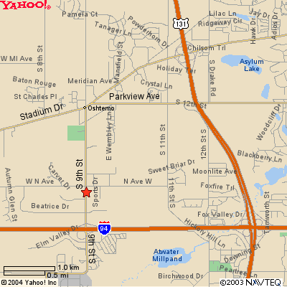

Hampton Inn (Kalamazoo-Oshtemo)
5059 S. 9th St.
KALAMAZOO, MI 49009
Tel: 1-269-372-1010
Fax: 1-269-372-1475

Gallagher’s (Formerly Chianti’s)
Gallagher’s is on Stadium Drive, about 2.5 miles north and east of the hotel.
4210 Stadium Drive
Kalamazoo, MI 49008
(269) 372-7177

Directions to The Lynx Golf Course from Hampton Inn

Take 9th st. North to Staduim, then turn right.
Take Staduim to US 131 and get on going north.
Follow US 131 north out of town to
Michigan State Road 89 (M89) west.
Follow M89 west through the small town of Otsego
and veer right still following M89.
The golf course will be on your left,
1 or 2 miles outside of town.

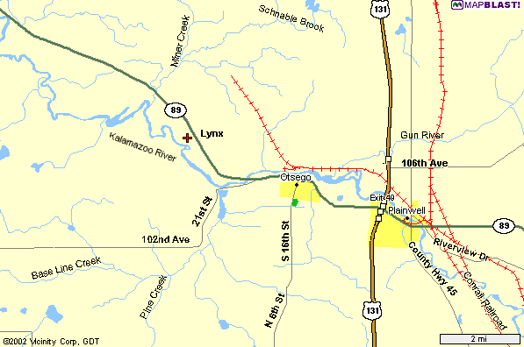

Lynx Golf Course

900 Lincoln Road (M89)

Otsego, Michigan 49078
1-269-694-5969
Directions to Thornapple Creek from Hampton Inn

Follow 9th St north to Stadium Av. Turn Right.
Follow Stadium Ave east to Drake Rd.
Turn Left on Drake and drive a few miles north to Ravine Rd.
Turn left on Ravine Rd. And follow it to “F” Ave.
Turn left on “F” Ave and follow to Thornapple, on the left side of the road.

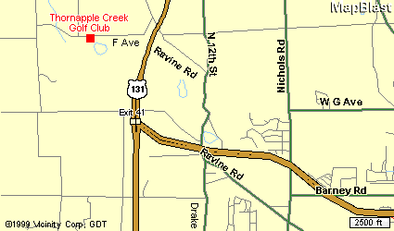

Thornapple Creek Golf Club
6415 W. F Ave
Kalamazoo, MI 49009
1-269-344-0040

(Alternate route to Thornapple from Hampton Inn)
Get on to US 131 North and follow it to the exit for “D” Ave.
Turn left onto D Ave, and drive 1 mile to Ravine Rd.
Turn left on Ravine Rd, and begin driving back south.
Follow the left fork to stay on Ravine Rd, and follow it to “F” Ave.
Turn right on “F” Ave. And follow it to Thornapple which will be on the left.
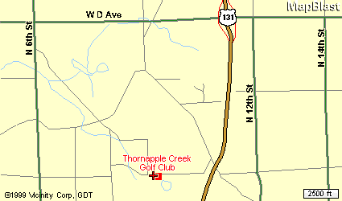

Directions to Heritage Glen from Hampton Inn

Take 9th St. north to Stadium Av. Turn Left.
Follow Stadium Drive west out of town.
Stadium will become “Red Arrow Highway”.
Follow Red Arrow Hwy west to 30th Street.
(Be patient, it is a few miles)
Turn right on 30th St. And follow to Heritage, about 1 or 2 miles down on right.

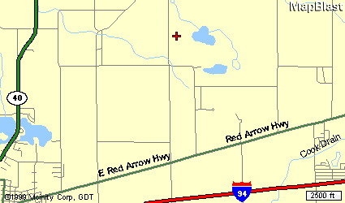

Heritage Glen Golf Club
29795 Heritage Lane
Paw Paw, MI 49079
1-269-657-2552



Lynx Golf Course

900 Lincoln Road (M89)

Otsego, Michigan 49078
(269) 694-5969

The clubhouse sets 135 feet above the river and the course meanders up and down the rolling hills that the property encompasses. The 8th hole is a par 5 with the green elevated 95 feet above the tee.
The par 4 10th hole offers 85 feet of drop from the tee to the fairway!

Many other holes offer elevation changes and breath taking scenic views that will remind the
golfer of their favorite Northern Michigan course.

Each hole is isolated by itself and gives the golfer the opportunity to enjoy the peace and solitude of the great outdoors. Most of the course is surrounded by river bottom land owned by the State of Michigan.
Thus, the course will always provide the peaceful solitude of a golf course in the woods.
At the Lynx, our golf holes are lined by a river and trees, not houses!

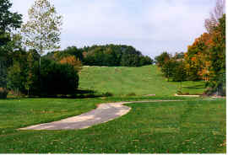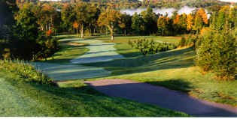

Blue Tees: Course Rating 71.2, Slope 137, 6471 yards
White Tees: Course Rating 69.1, Slope 134, 6012 yards



Thornapple Creek Golf Club
6415 West “F” Ave.
Kalamazoo, MI 49009
(269) 344-0040

Rated one of the most challenging courses by the Golf Association of Michigan. Enjoy a rare
combination of undisturbed natural beauty and finely manicured bent grass, a treat for any
golfer. The Creek’s 13th hole, a 618 yard par 5, was ranked as the best par 5 in the state, and
was also named to the Detroit Free Press’ “Dream 18”.

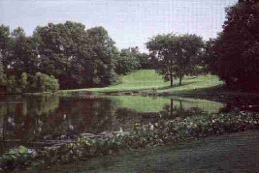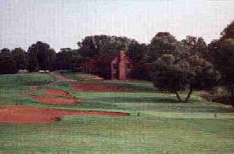

After your round enjoy the rustic log cabin clubhouse. Complete food and beverage service and
large seating capacity make it the ideal setting for heckling your fellow Otis participants as they
putt out on the 18th hole.

Blue Tees: Course Rating 72.3, Slope 133, 6595 yards
White Tees: Course Rating 70.0, Slope 127, 6122 yards


Heritage Glen Golf Club
29795 Heritage Lane
Paw Paw, MI 49079
(269) 657-2552

A challenging, public 18-hole, par 72 layout built on 235 acres of beautiful, rolling land in southwestern Michigan’s wine region. Opened in 1994, it is located five miles northeast of Paw Paw.

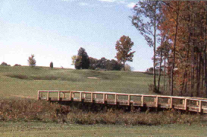
(The Adam Kommers Memorial Bridge)

On this beautifully maintained course, golfers enjoy three different settings on the front nine alone - pines, hardwoods, and a bit of the links effect. The bent grass greens, fairways, and tees are superbly manicured. Golfers need to make their mark on the front, because they wont be able to let up at all on the back nine!

The 6th hole is 625 yards from the back tees. It’s a narrow, double dogleg test that requires your best shot making ability.

Blue Tees: Course Rating 72.1, Slope 137, 6630 yards
White Tees: Course Rating 69.2, Slope 131, 6049 yards

