

The 8th Annual
Otis Invitational

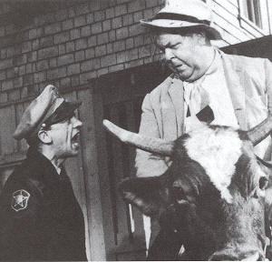
June 10, 11, 12 - 2005

Hosted By
Lynx Golf Course
Thornapple Creek Golf Club
Heritage Glen Golf Club

www.svs.com/zim/otis
 $6.25 
8th Annual Otis Invitational

Welcome Otis Participants!

This program will become your Otis bible, containing and pertaining to everything you could want to know about the tournament.

The most important rule, as always is to have a great time.

And in addition to the rules, this program contains prize money info, format, tee times, logistics, and of course, the now infamous Player Bios.

The logistics section includes directions, multiple maps, and for those of you who enjoy taking the back-roads, phone numbers for when you get lost.

Our final count for 2005 is at 40 players.

If you cannot play, let us know immediately, so we can fill your spot. Uneven scramble teams are no fun for anybody. Also, we have already committed to bring 40 people, and deposits have been paid. If we can’t replace you, you may not get a refund.

Make sure you reserve your room at the Hampton Inn. Call them at 269-372-1010. Rooms are approx. $89 per night double occupancy. Each room will have 2 double beds. To Reserve your room, call immediately for the Otis Golf Outing.

Tee times begin at 8:00 AM on Friday, 8:00 AM on Saturday and 7:30 AM on Sunday. Please make sure you get to the course ahead of time. Please show up for the first tee time even if you are not teeing off first.

Soft spikes are required, so bring a replacement set of spikes if you still use the metal ones.

Tee Markers: We will play the white tees for both individual rounds. At the Lynx, the blue tees for the scramble on Friday. At Thornapple, blues on the front nine, white on the back nine on Saturday, and the white tees for the scramble at Heritage on Sunday.

We will have a group dinner on Saturday at the Hampton Inn in Kalamazoo. We hope everyone will participate. The dinner price is included in your entrance fee, and includes appetizers, dinner buffet, beer, wine, and tip. Since we have a large group, there will be a buffet with steak chicken, and pasta.

We will also be meeting in the bar at Gallagher’s (formerly Chianti’s) on Thursday (after 9:00 p.m.) if you are interested in meeting up with many of the participants before the tournament.

The Prizes will be distributed as follows:

Closest To The Pin (4 holes per round, all 5 rounds) $30
Long Drive (1 hole per round, all 5 rounds) $40

Long Putt (2 holes per morning round) $30

Long Putt (2 holes per afternoon round) $30

Low Net 1st place (one person, each stroke play round) $50
Low Net 2nd place (one person, each stroke play round) $45
Low Net 3rd place (one person, each stroke play round) $40
Low Net 4th place (one person, each stroke play round) $35
Low Net 5th place (one person, each stroke play round) $25
Low Net 6th place (one person, each stroke play round) $20
Low Net 7th place (one person, each stroke play round) $15
Low Net 8th place (one person, each stroke play round) $10

Scramble Team Winners (each person, each scramble round) $50
Scramble Team 2nd place (each person, each scramble round) $40
Scramble Team 3rd place (each person, each scramble round) $30
Scramble Team 4th place (each person, each scramble round) $20
Scramble Team 5th place (each person, each scramble round) $15
Scramble Team 6th place (each person, each scramble round) $10

The golf fees for all 5 rounds will be $199 per person (includes green fees and riding cart, and lunch on Friday
and Saturday) Betting / prize / Saturday dinner money is $131 for the entire weekend.

Total cost per person: $330 (not including the hotel room.)

Birdie pool is optional. If you get in, you will pay $1 for every birdie made by others, and receive $1 from everyone else if you make a birdie. If someone scores an eagle, it will be counted as 2 birdies. A double eagle will count as 3 birdies. (Ya never know....)

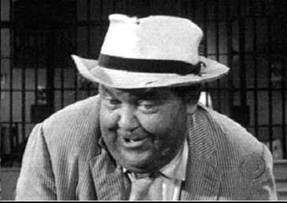

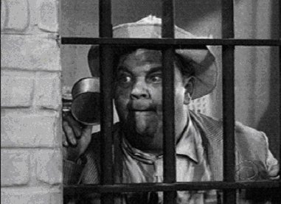

2005 Otis Invitational
Official Otis Format

Friday AM - Stroke play with your foursome at The Lynx. Prizes are awarded for the 4 closest to the pin markers, long drive in the fairway on #18, longest putt made on #9 & #18, and to the top 8 finishers. White tees.

Friday PM – 4 man scramble play at The Lynx. Teams are determined by a high/low pairing based on your pre-tournament approved score. For example, each team would consist of players ranked in the A, B, C, and D tiers (to be determined ahead of time.) Prizes are awarded for the 4 closest to the pin markers, long drive in the fairway on #18, longest putt made on #9 & #18, and to the top 6 teams. Blue Tees.

Saturday AM - Stroke play with your foursome at Thornapple. Prizes are awarded for the 4 closest to the pin markers, long drive in the fairway on #9, longest putt made on #9 & #18, and to the top 8 stroke play finishers.
White Tees.

Saturday PM - Handicapped 4 man scramble play at Thornapple. Teams are determined by a blind draw with two players from the “A” pool (players 1-20) and two from the “B” pool (players 21-40). Handicaps are computed based your pre approved average score. The scale is as follows: an Average score less than 80 is a
-1, 80-84 is a 0, 85-90 is a 1, 91-94 is a 2, 95-98 is a 3, 99-101 is a 4, 102-107 is a 5, and 108 or greater is a 6. If your team has players who average 85, 93, 96, and 112, you would receive a handicap of 12. Prizes are awarded for the 4 closest to the pin markers, long drive in the fairway on #18, longest putt made on 9 & 18, and to the top 6 teams. Blue tees on the front nine, white tees on the back nine.

Sunday AM - 4 man scramble play at Heritage. For this round, we have tried to draft even teams. Prizes are awarded for the 4 closest to the pin markers, long drive on #18, longest putt made on #9 & #18, and to the top 6 teams. White tees.
Official Otis Logistics

Tournament Date: Weekend of Friday, June 10, 2005

Tournament Location: The Lynx Golf Course (Friday)
Otsego, Michigan (269) 694-5969

Thornapple Creek Country Club (Saturday)
Kalamazoo, Michigan (269) 344-0040

Heritage Glen Golf Club (Sunday)
Paw Paw, Michigan (269) 657-2552

Motel Accommodations: Hampton Inn & Suites
(5059 S. 9th St. Exit 72 North, 269-372-1010)
Rooms are $89 per night double occupancy.
Each room will have 2 double beds.
Block of rooms reserved under the Otis Golf Outing

Saturday Night Dinner: We will have the entire group eat together at our hotel in Kalamazoo on Saturday night. Your dinner is included in the entry fee. Steak, Chicken & Pasta buffet will be provided with beer and wine included. For other meals, you are on your own. There are many good spots to eat around the hotel.

Tournament Format: 36 Holes on Friday and Saturday, 18 Holes on Sunday

Cost Breakdown: Greens Fees are $199 for the entire weekend. This includes 90 holes of golf,
($330 Total per person) and a riding cart. Betting, Prize and Dinner money is $131 for the entire weekend.
(for closest to the pin, low net, long drive, long putt, scramble winners, the dinner, and other goodies.)
Birdie pool is optional. If you get in, you will pay $1 for every birdie made by others, and receive $1 from everyone else for each birdie you make. Please send all checks to Rob Westover, 765 Dogwood Lane, Lake In The Hills, IL 60156.

Tee Times: Begin at 8:00 on Friday, 8:00 on Saturday, and 7:30 am on Sunday.

Player Handicaps: Your handicap will be determined by a mutually agreed upon average score.
If you have not played with us before, you will need to agree on a score with
someone who has. We will adjust your score up or down if we determine that
you normally play a very easy or difficult course. We ask you to be honest. The
competition will not be very much fun if there are a lot of “sandbaggers”.

Other information call Jason Zimberoff at 630-879-7761
Bump Waghorne at 630-736-8170
Rob Westover at 847-854-6625
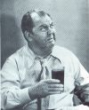
2005 Otis Invitational

Official Otis Rules

Unless otherwise stated by the rules committee (Jason, Bump and Mike), USGA rules apply. Here are some clarifications and local rules that should help eliminate confusion.

SHOW UP!
We go through a lot of planning to set up the Otis each year, so if you cannot make it, please do everything possible to tell us early and we will try to find a replacement. Uneven scramble teams are not fun for anybody. If you play, you will be among the first to get invited back every year!

PLAY WHEN YOU ARE SCHEDULED!

It is difficult to set up the tee times so that people do not play with the same foursome every day, and still
keep teams fairly even. If you cannot play in the first or last tee time Sunday morning, you are not Otis material and you should stay home! Even though your odds are good that you will play when you want, be prepared to stick it out until the last minute. Do not assume you can get home early on Sunday. Make your travel plans accordingly. You have been warned.

NO COMPLAINING about the conditions or rules!

NO GIMMIES!

KEEP PACE:
Please take no more than 10 strokes per hole. If you hit the ball 10 times and are still not in the hole,
give it up and move on!
Please keep up with the group ahead of you. We need to get a lot of people through the course in time
to tee off again in the afternoon, and we do not want dinner to be later than it has to be.

RAIN:
You are expected to play through all weather. We follow a modified Otis rule.(The original Otis rule is, if the bar is open, you must drink!), thus the modified rule is, if the course is open you must play. With this in mind, be prepared with an umbrella, rain suit, multiple towels, and spare gloves. As Bill Murray would say, “I don’t think the hard stuff will come down for a while” Remember, we are coming a long way to play, so be prepared! Besides, everyone will face the same conditions.

SHIRTS & SHOES:
Soft Spike shoes are required. Most of us have converted by now, but it is still worth mentioning. Please wear shirts with a collar.

TEE TIMES
Arrive at least 20 minutes before your morning tee time.

MOVING THE BALL:
Fairway and Rough- You are allowed to move the ball no more than six inches

OUT OF BOUNDS:
All Courses - All holes - you are allowed to drop the ball where it went OB with a ONE stroke penalty.

If the ball is OB but playable, you still must drop it back in play and take the one stroke penalty!

LOST BALLS: (This year’s honoree is Jason Zimberoff, who was married on May 22, 2004…) You may drop a ball in the area where you think the ball disappeared (you must get agreement from your partners on the spot), and then take a ONE stroke penalty.

WATER HAZARDS:
Standard - Drop where the ball crossed the margin of the hazard, one stroke penalty (i.e., on a par 3
if you hit your tee shot in the water, after your drop, you will be hitting your 3rd shot.)
Exceptions - #4 at Thornapple: Off the tee, drop on the other side of the marsh by the cart path
#5 at Thornapple: Off the tee, drop on the other side of the lake directly in front of the tee
#17 at Thornapple: Off the tee, drop in the official drop area (if marked), otherwise,
drop just short and to the right of the green.
#11 at Heritage Off the tee, drop on the other side of the marsh.
#16 at Heritage Off the tee, drop on the other side of the lake.

SCORECARDS:
Must be signed by each member of the group and given to Zim after each round.

SCRAMBLES:
Drives: Minimum of 2 drives must be used from each player
Position - You must hit your shot within 1 club length of where the ball was marked. You can
not change the playing surface (i.e., if you are in the rough or sand you must play the ball from
the rough or sand). Also, you may not move the ball closer to the hole.
Putting: Once the ball is in the hole, that is your score (i.e., DON’T tap the ball in if someone else still
has a chance to make the putt!!)
Finish: Weather permitting, wait at least 30 feet behind the green for the following groups.

Friday Morning Individual Score
Name | Otis Score | PM Group
Larry Ryan | 95 | 6
Tom Westerholm | 92 | 9
Bill Wahl | 96 | 3
Darryl Krumwiede | 92 | 10
Randy Comstock | 115 | 2
Scott Kossman | 105 | 8
Paul Hanson | 100 | 1
Mark Fankhanel | 95 | 7
Mike Redenbaugh | 85 | 4
Jason Zimberoff | 95 | 5
Jordan Zimberoff | 98 | 10
Ken Redenbaugh | 112 | 1
Dave Compton | 95 | 10
John Steffensen | 88 | 8
Pat DiDomenico | 98 | 5
Mike Reda | 98 | 1
Jeff Lake | 102 | 6
John Wucki | 104 | 9
Jim Spade | 115 | 3
Mark Lutz | 105 | 7
Adam Kommers | 85 | 6
Rob Rains | 108 | 5
Tim Monti | 98 | 4
Brandan Mueller | 98 | 2
Bryan Rehfeldt | 98 | 8
John Hayes | 102 | 3
Steve Rehfeldt | 108 | 6
John Iannantuoni | 98 | 7
Ron Blink | 82 | 3
Rob Westover | 115 | 4
Bill Krueger | 85 | 5
Lance Murphy | 98 | 2
Joe Booth | 104 | 10
Bill Fry | 80 | 2
Steve Ryan | 95 | 8
Kevin Van Alstyne | 98 | 9
Randy Hill | 78 | 1
Patrick Mackey | 92 | 9
Greg Wilson | 86 | 7
Phil Joschko | 98 | 4
Friday Afternoon Scramble
Name Otis Score
Randy Hill | 78
Mike Reda | 98
Paul Hanson | 100
Ken Redenbaugh | 112
Bill Fry | 80
Lance Murphy | 98
Brandan Mueller | 98
Randy Comstock | 115
Ron Blink | 82
John Hayes | 102
Bill Wahl | 96
Jim Spade | 115
Mike Redenbaugh | 85
Tim Monti | 98
Phil Joschko | 98
Rob Westover | 115
Bill Krueger | 85
Jason Zimberoff | 95
Pat DiDomenico | 98
Rob Rains | 108
Adam Kommers | 85
Larry Ryan | 95
Jeff Lake | 102
Steve Rehfeldt | 108
Greg Wilson | 86
Mark Fankhanel | 95
John Iannantuoni | 98
Mark Lutz | 105
John Steffensen | 88
Steve Ryan | 95
Bryan Rehfeldt | 98
Scott Kossman | 105
Tom Westerholm | 92
Pat Mackey | 92
Kevin Van Alstyne | 98
John Wucki | 104
Daryl Krumwiede | 92
Dave Compton | 95
Jordan Zimberoff | 98
Joe Booth | 104

Saturday Morning Individual Score
 | Name | Otis Score | PM Group
 | Randy Hill | 78 | 1
 | Bill Fry | 80 | 2
 | Greg Wilson | 86 | 7
 | Mike Redenbaugh | 85 | 4
 | Kevin Van Alstyne | 98 | 4
 | Mark Lutz | 105 | 4
 | Mike Reda | 98 | 5
 | Rob Westover | 115 | 9
 | Bill Kruger | 85 | 5
 | Lance Murphy | 98 | 1
 | Pat Mackey | 92 | 8
 | John Iannantuoni | 98 | 6
 | Rob Rains | 108 | 3
 | Steve Ryan | 95 | 7
 | Larry Ryan | 95 | 9
 | Daryl Krumwiede | 92 | 10
 | John Steffensen | 88 | 8
 | Ron Blink | 82 | 3
 | Adam Kommers | 85 | 6
 | Bill Wahl | 96 | 4
 | Tom Westerholm | 92 | 9
 | Phil Joschko | 98 | 5
 | Joe Booth | 104 | 2
 | Scott Kossman | 105 | 7
 | Bryan Rehfeldt | 98 | 2
 | Steve Rehfeldt | 108 | 10
 | John Hayes | 102 | 1
 | Ken Redenbaugh | 112 | 6
 | Jim Spade | 115 | 1
 | Jason Zimberoff | 95 | 6
 | Paul Hanson | 100 | 8
 | Randy Comstock | 115 | 5
 | John Wucki | 104 | 8
 | Jeff Lake | 102 | 2
 | Mark Fankhanel | 95 | 10
 | Dave Compton | 95 | 3
 | Brandon Mueller | 98 | 9
 | Tim Monti | 98 | 3
 | Pat DiDomenico | 98 | 10
 | Jordan Zimberoff | 98 | 7
Saturday Afternoon Scramble
Name Otis Score HCP Team HCP
Randy Hill | 78 | -1
Lance Murphy | 98 | 3
John Hayes | 100 | 5
Jim Spade | 115 | 6 | 13
Bill Fry | 80 | 0
Bryan Rehfeldt | 98 | 3
Jeff Lake | 102 | 5
Joe Booth | 104 | 5 | 13
Ron Blink | 81 | 0
Dave Compton | 95 | 3
Tim Monti | 98 | 4
Rob Rains | 108 | 6 | 13
Mike Redenbaugh | 85 | 1
Bill Wahl | 95 | 3
Kevin Van Alstyne | 99 | 4
Mark Lutz | 105 | 5 | 13
Billy Kruger | 85 | 1
Mike Reda | 98 | 3
Phil Joschko | 98 | 4
Randy Comstock | 115 | 6 | 14
Adam Kommers | 85 | 1
Jason Zimberoff | 95 | 3
John Iannantuoni | 98 | 3
Ken Redenbaugh | 112 | 6 | 13
Greg Wilson | 86 | 1
Steve Ryan | 95 | 3
Jordan Zimberoff | 98 | 4
Scott Kossman | 105 | 5 | 13
John Steffensen | 88 | 1
Patrick Mackey | 92 | 2
Paul Hanson | 102 | 5
John Wucki | 104 | 5 | 13
Tom Westerholm | 92 | 2
Larry Ryan | 96 | 3
Brandon Mueller | 98 | 3
Rob Westover | 115 | 6 | 14
Daryl Krumwiede | 92 | 2
Mark Fankhanel | 95 | 3
Pat DiDomenico | 98 | 4
Steve Rehfeldt | 108 | 6 | 15

Sunday Morning Scramble

Name
Randy Hill | 78
John Iannantuoni | 98
Bryan Rehfeldt | 98
Jeff Lake | 102
Bill Fry | 80
Paul Hanson | 100
Mike Reda | 98
Jim Spade | 115
Ron Blink | 82
Bill Wahl | 96
Pat DiDomenico | 98
Rob Westover | 115
Mike Redenbaugh | 85
Jason Zimberoff | 95
Ken Redenbaugh | 112
Steve Rehfeldt | 108
Bill Krueger | 85
Lance Murphy | 98
Tim Monti | 98
John Hayes | 102
Greg Wilson | 86
Dave Compton | 95
Joe Booth | 104
Randy Comstock | 115
Adam Kommers | 85
Steve Ryan | 95
Kevin Van Alstyne | 98
Rob Rains | 108
John Steffensen | 88
Mark Fankhanel | 95
Jordan Zimberoff | 98
Mark Lutz | 105
Tom Westerholm | 92
Larry Ryan | 95
Phil Joschko | 98
John Wucki | 104
Daryl Krumwiede | 92
Pat Mackey | 92
Brandan Mueller | 98
Scott Kossman | 105

Player Bios

This is the famous Otis Bio section. If you have a better nickname, tell

Bump, Rob, Mike, or Zim and we will change it next time...

Score Name Otis Nickname Information

78 Randy Hill "The LSU Under-stater" “I am not playing that well” may be heard frequently as he makes boring two putt pars.
When he gets it going and rips off back to back birdies, as in his first Otis two years ago,
you may hear "a few more holes, and I might get my rhythm". Sweet Jesus, if he gets that
rhythm, watch out Tiger.

80 Bill Fry (New Player) As a buddy of Greg Wilson, we need to tell him he doesn’t need to earn Otis poster boy
status every night, and that golf at the Otis is not live or die (if only Greg had followed that
advice at his first Otis, someone else would have had a chance to win). We are guessing
that he does take odds on anything, just like Greg "I'll bet you on that" Wilson. As such, it
is advised you don't.

82 Ron Blink “Young Gun” Do we finally have somebody that can out-drive Redenbaugh? Ron will be the youngest
player in the field, and hits a huge ball. This is his first Otis – so welcome and good luck!

85 Mike Redenbaugh “Hoser” Mike has shifted his golf attention to his other hobby – fishing. Spending more time on his
boat than the golf course has put a damper on his game, but he can also get hot quickly.
Look for Mike to reel in a few birdies, and maybe a bluegill or two while he is at it.

85 Bill Krueger “Billy Baroo” Billy might have allowed his softball swing to screw up his golf swing. We finally got him to
drive the ball at the plate, but it might mean he can no longer drive the ball on the tee.

85 Adam Kommers “Rowdy Roddy Piper” Adam is now father with a full time job and a mortgage. Any time for golf? Sure – he lives
near San Diego! Has he practiced enough to regain the Otis scoring title? Probably not.
Congratulations on the arrival of your first child – a son! Buy him any clubs yet?

86 Greg Wilson "I am feeling it" In his first Otis as anchor of a scramble team, he allegedly knocked over two teammates to
hit a shot on the 13th at Thornapple, as he claimed he was "feeling it". Normally, we think
that is a personal matter not to be shared, but in this case it was the shot - which he holed
for eagle from 145 away in a hung-over state. It seems Greg was feeling it all weekend
long, as his scramble teams came in 1st, 1st and 2nd. Lets hope he stays more sober this
year and plays like the rest of us.

88 John Steffensen “The Iron Man” Returning for his 3rd Otis, you will rarely catch John with a driver in his hand. Preferring to
play it safe and use his irons exclusively, don’t be surprised to learn that he doesn’t really
need the woods! John is also now the undisputed #1 Lefty in the field!

92 Tom Westerholm "One for the road" One of the new Ryan Ringers, Tom fit right in last year by stealing a playoff win over the
long time veteran champion Baugh team. While allegations of improprieties arose about
the stunning win, in the end it was determined that these allegations of slacking on the Otis
standard by Tom's team were false. Their actions proved them true Otis players, as Tom
and Matt Streeter - in the glory of victory - walked back to the club house. Unfortunately,
they left their clubs and cart behind. Thank god for the more sober, quicker thinking (and
that is not saying very much) Steve Olson, who ran back and rescued their clubs before
pouring Tom and the team into his car for a drive back to the hotel.

92 Darryl Krumwiede “Brother Darryl” Darryl didn’t play as well last year, but for some reason the Otis gods assumed he was still
consistent, and left his score the same as last year. Don’t ask me why. I just write the
bios. Maybe another year of higher numbers will finally sway the gods to give him a break
next year.

92 Pat Mackey "Late Night" Famous for his activities after the golf day is done - he met more people in his last night in
Kalamazoo than we will know in our lives. Remember - when someone asks you if met
this guy from the Wiggles who was out and about last night, just nod knowing it is "late
night" they are referring to, and don’t ask for details.

95 Steve Ryan “The Putt” Steve hosted everyone at his cottage on the lake last year. Too bad it was because we
got rained out for our practice round on Thursday. Beer, chips, and a leaky roof in the
porch. It doesn’t get any better than this!

95 Larry Ryan “The Ringleader” Larry is back after a year off from the Otis. We are all glad to see you back! We used to
use this space to ask him when he will have that breakout year. Oh well, I guess we asked
again! Welcome back and good luck!

95 Mark Fankhanel "Where's My Sunscreen" Although there are many follicularly challenged Otis brethren, Mark is the only one known
to have taken off his ball cap, as a strategic maneuver, to temporally blind two other scramble foursomes. While his team may have come in 3rd as a result of his, "if we cant hit it closer to the pin, they wont be able to see the pin” approach, this little tactic will not soon be forgotten.

95 Dave Compton “Night Train” If you find yourself awakened in the middle of the night at the hotel this year, you may think
that we found the only hotel in Kalamazoo that was built next to the freight train tracks.
Fear not though, that’s only Dave snoring in his room. Dave has been very consistent at
the Otis lately, and looks to continue his quiet winning ways again this year.

95 Jason Zimberoff “Zim” Zim’s low-teens handicap days are long behind him now. He just celebrated his first
anniversary, bought a new house last fall, and spends most of his time organizing a
Mustang car club in Chicago. But after going 10 months without practicing, playing or
even touching his clubs – he still beat his brother by 3 on the front nine earlier this week.

96 Bill Wahl “The Set Up Man” Bill is returning to us after a year away from the Otis. Lots of smiles, tons of beer, and
inconsistent golf describe him. Bill lost his title of the best golfer from the “Ryan Ringers”
a while back. Is he losing it, or are the others just that much better now?

98 John Iannantuoni “Johnny Credit” Winner of the “most impossible to spell last name” category, John will henceforth be
referred to as “John I”. He also finished 14 shots under his score for the whole weekend
last year. That means a much lower score this year! Can he live up to it?

98 Lance Murphy “Murph” Lance shot 106 and 90 in the two individual rounds last year, so we once again are curious
about which Lance will show up this year… The one who is really lousy? Or the one who
is just sort of lousy?

98 Mike Reda “Choke” Mike didn’t beat his Otis score at all last year, surprising the Otis gods. Can he ever find
the magic that allowed him to break 90 here in the days of lore? Probably not. Can he
break 98 though? Choke is on the bubble… will his score go up or down next year?

98 Bryan Rehfeldt “The Professor” Bryan dropped into the ranks of the sub-100 golfers for the first time last year, and fired a
107 and a 90. He says he has been playing a lot this year again, so stay tuned for this
year’s unpredictable numbers!

98 Brandan Mueller “Rip Van Winkle” Brandan was recently mortally wounded by a spider bite, and is already making excuses
about how it will adversely affect his game. He plays well in the state of Illinois.
Unfortunately for him, the Otis is in Michigan.

98 Kevin Van Alstyne “The Van” For years the Otis has been in search of a designated driver of the non golf variety. Finally
we believe we have found one, as Kevin comes with his own “Van”. He looks just like and
hits the ball as short as Corey Pavin, but don’t ask him to wear a visor, as he may snap.
We don’t want to lose the driver of our 8 passenger minivan. In all honesty Kevin has
been working on his game and is very close to breaking 90 on a good day, on the bad
days he takes 8's on par 3's. Welcome and good luck!

98 Tim Monti “Coach” Tim is still playing baseball, but his dreams of playing catcher for the Cubs have all but
vanished nowadays. If Tim could ever find a short game to equal his distance off the tee, he’s be a good bet to score like an A player. But since he is coming off a foot injury, look
for Tim in your local bunker.

98 Pat DiDomenico “Dee-Doe” They say practice makes perfect. If that was true, Pat would be the number one player at
the Otis. He’s put a lot of time and effort into his game, and comes back this year exactly
where he was last year. But this year he has new irons, and is reported to be hitting them
pretty well. Good luck!

98 Jordan Zimberoff “Little Zim” Jordan is finally done with grad school classes and is continuing to do the bartender by
night thing… late evenings, and lots of drinking… He should be in the best Otis condition
of anyone. But that’s what we said last time too. If we had an award for “longest drive
straight up in the air” Jordan would win it every time. Distance off the tee is not too bad,
but wow – what hang time!

98 Phil Joschko “Mr. Mermaid” Phil was once again the model of consistency last year – sitting in the same chair at
Mermaids all 3 nights. That is why he is returning this year with the same score! Hang on
to your singles!

100 Paul Hanson “Slap Shot” Look for Paul at the Heineken tent if it starts to rain. Actually, you can look for him there if
the sun is out too.

102 John Hayes “The Anchor Man” John’s bowling game improved over the winter, so it only stands to reason that his golf
game will get better too. Of course, you would also think that the odds are good that the Cubs would win the world series at least once every 97 years.

102 Jeff Lake “Mr. Demo Day” A wise old golfer once said that the answer to one’s golf woes was “take two weeks off –
and then quit.” Jeff has a different philosophy – “take two weeks off – and then replace all
of your golf clubs”. I think he currently has a nice set of Ping irons for sale in his trunk.

104 Joe Booth “Jo Mamma” Joe returns after missing a year. He has played well in the past at the Otis, but may still
be a little rusty. Welcome back and good luck!

104 John Wucki “Can I Buy A Nickname?” John is becoming a regular at the Otis, and even tied his friend Jeff Lake last year for total
shots in the individual rounds. Will he finally beat Jeff this year? Will Zim finally come up
with a real nickname for him? Who knows?

105 Scott Kossman “Koss” Every year we wonder if Scott will wake up and play better, and every year we got the
same answer. Until last year… He fired a 95 on Saturday last year. Where the heck did
that come from? Was it a fluke, or should we all be worried?

105 Mark Lutz "Never-Never Land" Mark recently remarried, had another boy, took a time demanding job, and bought a new
house - all in the last 10 months. His golf game is nonexistent, and he thinks he just needs
to get out more to improve his game. He is right, but our guess is it will be ten years
before that happens. So for now, with his lack of a golf game, he tends to send many a
ball to never-never land.

108 Steve Rehfeldt “Radar” The Otis gods were not kind to Steve last year. The glory days of beating his brother long
past, he now spends his spare time donating golf balls to the bluegills. All things
considered, he’d probably rather be in Philadelphia. (apologies to W.C. Fields)

108 Rob Rains “Big Rob II” Adam’s cousin Rob returns this year, and looks to retain his title as the low scorer among
guys nicknamed “Big Rob”. Considering his competition, we think he should have a pretty
easy time of it again.

112 Ken Redenbaugh “Pa Baugh” Without Ken, there would probably be no Otis. He was one of the original guys to come up
to Kalamazoo with his old neighbor to play in the “Lapski” tournament. Many divots and
lost balls later, Ken is still at it and wouldn’t have it any other way.

115 Jim Spade “Chief” Jim and Zim followed the Illini on their road to the final four this spring, and all they came
home with (besides 5 wins) was a head cold and a hangover. Never afraid of what the
crowd will think, Jim has been known to do his Chief Illiniwek impersonation at weddings
and bar-mitzvahs. Give him a free beer, and he might do the 3-in-1 for you too!

115 Randy Comstock "Batman" Mild mannered and meek golf game by morning, add a few drinks, and he turns into a
superhero downing tall Captain and Cokes in a single bound, trading fantasy football players at a suggestion of an injury. Maybe he will even hit a driver off the tee - and surely
he will be telling Bump he is clueless about life. Unfortunately for Randy, most super heroes aren’t great golfers, and thus Randy, Bruce Wayne, and Batman still are "D"
players.

115 Rob Westover “Big Rob” Rob has climbed back into the Otis basement this year, after carding a big score in a
shortened appearance last June. He claims to be on the road to recovery though. You
have to admire a man with optimism in the face of certain duck-hooking.

Otis Invitational History

Long ago there was a group of guys who played golf on Sunday Mornings at Arrowhead golf course in Wheaton. One of them was Terry Bulger, who worked for a bank in Chicago. One day (sometime in the late ‘80’s ) Terry asked two of his golfing partners - Ken Redenbaugh and his son Mike – if they would like to join him in a golf outing run by some of the guys he worked with at the bank.

These two co-workers had organized a golf outing in Kalamazoo Michigan at Thornapple Creek golf course, and played 90 holes there in three days. The group made up of mostly bank employees and their friends was called the Lapski – after its co-organizers named Gonski and Lapitina.

Back then, Thornapple was a course unlike any that they had seen. Rolling terrain, a great layout with lots of trouble, and unbelievably fast greens. It was truly a golf paradise.

Terry, Mike and Ken played in the Lapski for a number of years – occasionally adding a few other neighbors and friends to the group. Eventually, Mike asked his friend Jason Zimberoff to join the group.

By this time, the Lapski group had grown to about 40 men, but the quality of the greens at Thornapple started to fall off from the glory days. So, they had also added another course to the schedule on Saturdays, called Heritage Glen. The Friday and Sunday rounds were still played at Thornapple though.

The Lapski golfers were also more serious about the winning and scoring, and it sometimes led to a lot of under-the-breath muttering about sandbaggers and people not following the rules. It did sometimes take away from what we thought the spirit of the trip should be.

With the addition of Jason Zimberoff also came many of his friends and family members. After a couple of
years, Mike and Jason were bringing at least 12 guys to Michigan with them to play in the Lapski – and a great time was had by all…

Until one dark day at the beginning of 1998, Mike got the phone call that changed history forever. The Lapski group wanted to go back to inviting more of the bank employees and more of their friends, and we were asked to only bring 4 players that coming summer.

That was all we needed to hear. How could we choose who could and couldn’t go? Would we hang our heads and agree to this? NO!

The group of Mike Redenbaugh, Jason Zimberoff, Bump Waghorne, and Rob Westover, all former Lapski players, decided to create a new outing based on the self-described “Oti” (pronounced oat-eye) club of over-served
drinking buddies… named, of course, after everyone’s favorite town drunk – Otis Campbell of Mayberry.

We immediately got together and came up with the idea for the Otis Invitational. A group that would be made up of all of our friends and family. Although we did bring many of the long-time Lapski guys with us, we hope that we left all of the bickering and BS with the old group. We even replaced the Sunday individual scoring round with a scramble to make it more fun – along with a few other minor changes that we all wanted to make.

This year, we again return to Kalamazoo with 44 of our own players, and three golf courses! We wouldn’t have it any other way. Thanks to everybody who has participated these eight years, and here’s to 50 more!

Directions to the Hampton Inn from Chicago

Take the tri-state toll way south towards Indiana.
Follow 294 south to 80-94 east.
Stay on I-94 all the way into Michigan and to Kalamazoo.
Exit I-94 at 9th Street (Exit 72 North).
Follow 9th Street north to the hotel.

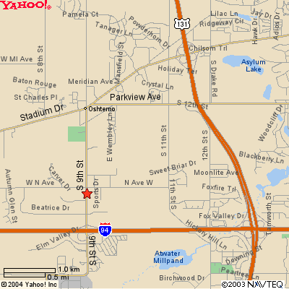

Hampton Inn (Kalamazoo-Oshtemo)
5059 S. 9th St.
KALAMAZOO, MI 49009
Tel: 1-269-372-1010
Fax: 1-269-372-1475

Gallagher’s (Formerly Chianti’s)
Gallagher’s is on Stadium Drive, about 2.5 miles north and east of the hotel.
4210 Stadium Drive
Kalamazoo, MI 49008
(269) 372-7177

Directions to The Lynx Golf Course from Hampton Inn

Take 9th st. North to Staduim, then turn right.
Take Staduim to US 131 and get on going north.
Follow US 131 north out of town to
Michigan State Road 89 (M89) west.
Follow M89 west through the small town of Otsego
and veer right still following M89.
The golf course will be on your left,
1 or 2 miles outside of town.

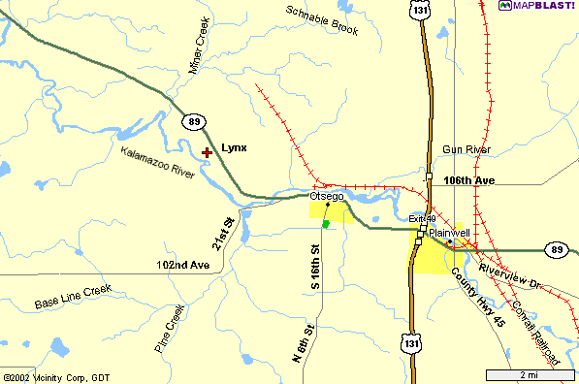

Lynx Golf Course

900 Lincoln Road (M89)

Otsego, Michigan 49078
1-269-694-5969
Directions to Thornapple Creek from Hampton Inn

Follow 9th St north to Stadium Av. Turn Right.
Follow Stadium Ave east to Drake Rd.
Turn Left on Drake and drive a few miles north to Ravine Rd.
Turn left on Ravine Rd. And follow it to “F” Ave.
Turn left on “F” Ave and follow to Thornapple, on the left side of the road.

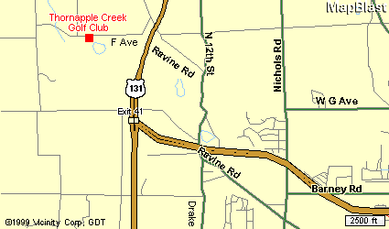

Thornapple Creek Golf Club
6415 W. F Ave
Kalamazoo, MI 49009
1-269-344-0040

(Alternate route to Thornapple from Hampton Inn)
Get on to US 131 North and follow it to the exit for “D” Ave.
Turn left onto D Ave, and drive 1 mile to Ravine Rd.
Turn left on Ravine Rd, and begin driving back south.
Follow the left fork to stay on Ravine Rd, and follow it to “F” Ave.
Turn right on “F” Ave. And follow it to Thornapple which will be on the left.
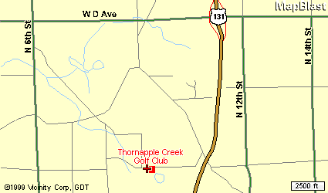

Directions to Heritage Glen from Hampton Inn

Take 9th St. north to Stadium Av. Turn Left.
Follow Stadium Drive west out of town.
Stadium will become “Red Arrow Highway”.
Follow Red Arrow Hwy west to 30th Street.
(Be patient, it is a few miles)
Turn right on 30th St. And follow to Heritage, about 1 or 2 miles down on right.

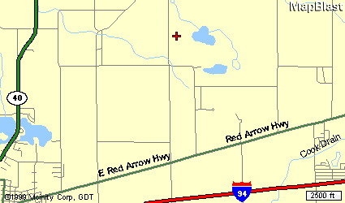

Heritage Glen Golf Club
29795 Heritage Lane
Paw Paw, MI 49079
1-269-657-2552



Lynx Golf Course

900 Lincoln Road (M89)

Otsego, Michigan 49078
(269) 694-5969

The clubhouse sets 135 feet above the river and the course meanders up and down the rolling hills that the property encompasses. The 8th hole is a par 5 with the green elevated 95 feet above the tee.
The par 4 10th hole offers 85 feet of drop from the tee to the fairway!

Many other holes offer elevation changes and breath taking scenic views that will remind the
golfer of their favorite Northern Michigan course.

Each hole is isolated by itself and gives the golfer the opportunity to enjoy the peace and solitude of the great outdoors. Most of the course is surrounded by river bottom land owned by the State of Michigan.
Thus, the course will always provide the peaceful solitude of a golf course in the woods.
At the Lynx, our golf holes are lined by a river and trees, not houses!

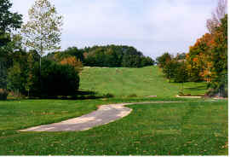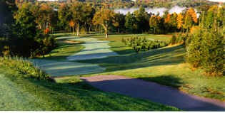

Blue Tees: Course Rating 71.2, Slope 137, 6471 yards
White Tees: Course Rating 69.1, Slope 134, 6012 yards



Thornapple Creek Golf Club
6415 West “F” Ave.
Kalamazoo, MI 49009
(269) 344-0040

Rated one of the most challenging courses by the Golf Association of Michigan. Enjoy a rare
combination of undisturbed natural beauty and finely manicured bent grass, a treat for any
golfer. The Creek’s 13th hole, a 618 yard par 5, was ranked as the best par 5 in the state, and
was also named to the Detroit Free Press’ “Dream 18”.

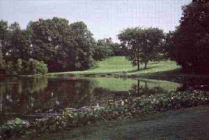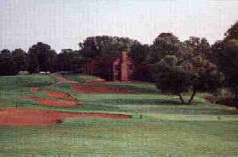

After your round enjoy the rustic log cabin clubhouse. Complete food and beverage service and
large seating capacity make it the ideal setting for heckling your fellow Otis participants as they
putt out on the 18th hole.

Blue Tees: Course Rating 72.3, Slope 133, 6595 yards
White Tees: Course Rating 70.0, Slope 127, 6122 yards


Heritage Glen Golf Club
29795 Heritage Lane
Paw Paw, MI 49079
(269) 657-2552

A challenging, public 18-hole, par 72 layout built on 235 acres of beautiful, rolling land in southwestern Michigan’s wine region. Opened in 1994, it is located five miles northeast of Paw Paw.

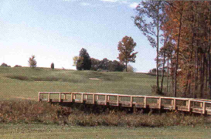
(The Adam Kommers Memorial Bridge)

On this beautifully maintained course, golfers enjoy three different settings on the front nine alone - pines, hardwoods, and a bit of the links effect. The bent grass greens, fairways, and tees are superbly manicured. Golfers need to make their mark on the front, because they wont be able to let up at all on the back nine!

The 6th hole is 625 yards from the back tees. It’s a narrow, double dogleg test that requires your best shot making ability.

Blue Tees: Course Rating 72.1, Slope 137, 6630 yards
White Tees: Course Rating 69.2, Slope 131, 6049 yards

