

The 9th Annual
Otis Invitational

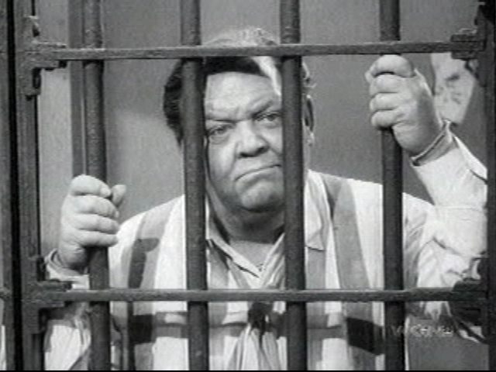
June 9, 10, 11 - 2006

Hosted By
Lynx Golf Course
Thornapple Creek Golf Club
Heritage Glen Golf Club

www.svs.com/zim/otis
 $6.50 
9th Annual Otis Invitational

Welcome Otis Participants!

This program will become your Otis bible, containing and pertaining to everything you could want to know about the tournament.

The most important rule, as always is to have a great time.

And in addition to the rules, this program contains prize money info, format, tee times, logistics, and of course, the now infamous Player Bios.

The logistics section includes directions, multiple maps, and for those of you who enjoy taking the back-roads, phone numbers for when you get lost.

Our final count for 2006 is at 36 players.

If you cannot play, let us know immediately, so we can fill your spot. Uneven scramble teams are no fun for anybody. Also, we have already committed to bring 36 people, and deposits have been paid. If we can’t replace you, you may not get a refund.

Make sure you reserve your room at the Holiday Inn. Call them at 269-375-6000. Rooms are approx. $99 per night double occupancy. Each room will have 2 double beds. To Reserve your room, call immediately for the Otis Golf Outing.

Tee times begin at 7:45 AM on Friday, 7:45 AM on Saturday and 7:30 AM on Sunday. Please make sure you get to the course ahead of time. Please show up for the first tee time even if you are not teeing off first.

Soft spikes are required, so bring a replacement set of spikes if you still use the metal ones.

Tee Markers: We will play the white tees for both individual rounds. At the Lynx, the blue tees for the scramble on Friday. At Thornapple, blues on the front nine, white on the back nine on Saturday, and the white tees for the scramble at Heritage on Sunday.

We will have a group dinner on Saturday at the Holiday Inn in Kalamazoo. We hope everyone will participate. The dinner price is included in your entrance fee, and includes appetizers, dinner buffet, beer, wine, and tip. Since we have a large group, there will be a buffet with steak chicken.

We will also be meeting in the bar at Gallagher’s (formerly Chianti’s) on Thursday (after 9:00 p.m.) if you are interested in meeting up with many of the participants before the tournament.

The Prizes will be distributed as follows:

Closest To The Pin (4 holes per round, all 5 rounds) $25
Long Drive (1 hole per round, all 5 rounds) $25

Long Putt (2 holes per morning round) $25

Long Putt (2 holes per afternoon round) $25

Low Net 1st place (one person, each stroke play round) $50
Low Net 2nd place (one person, each stroke play round) $45
Low Net 3rd place (one person, each stroke play round) $40
Low Net 4th place (one person, each stroke play round) $35
Low Net 5th place (one person, each stroke play round) $25
Low Net 6th place (one person, each stroke play round) $20
Low Net 7th place (one person, each stroke play round) $15
Low Net 8th place (one person, each stroke play round) $10

Scramble Team Winners (each person, each scramble round) $40
Scramble Team 2nd place (each person, each scramble round) $30
Scramble Team 3rd place (each person, each scramble round) $20
Scramble Team 4th place (each person, each scramble round) $15
Scramble Team 5th place (each person, each scramble round) $10

The golf fees for all 5 rounds will be $198 per person (includes green fees and riding cart, and lunch on Friday
and Saturday) Betting / prize / Saturday dinner money is $152 for the entire weekend.

Total cost per person: $350 (not including the hotel room.)

Birdie pool is optional. If you get in, you will pay $1 for every birdie made by others, and receive $1 from everyone else if you make a birdie. If someone scores an eagle, it will be counted as 2 birdies. A double eagle will count as 3 birdies. (Ya never know....)

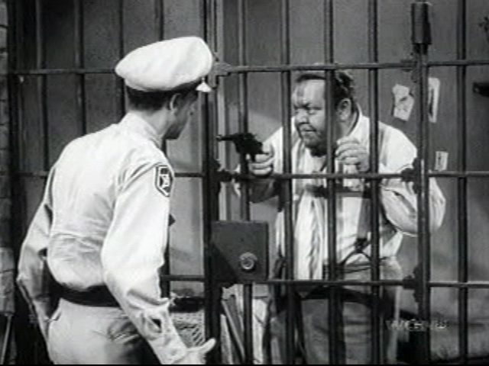

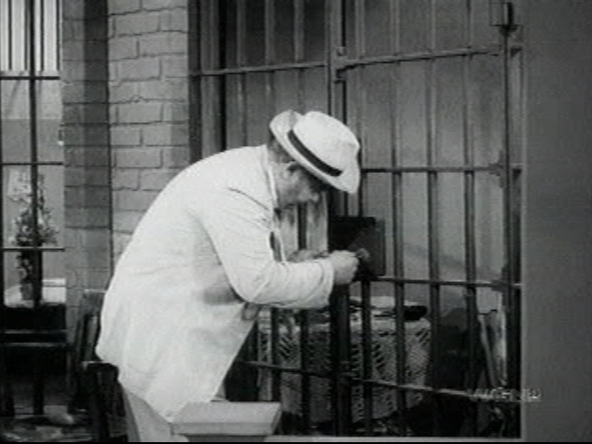

2006 Otis Invitational
Official Otis Format

Friday AM - Stroke play with your foursome at The Lynx. Prizes are awarded for the 4 closest to the pin markers, long drive in the fairway on #17, longest putt made on #9 & #18, and to the top 8 finishers. White tees.

Friday PM – 4 man scramble play at The Lynx. Teams are determined by a high/low pairing based on your pre-tournament approved score. For example, each team would consist of players ranked in the A, B, C, and D tiers (to be determined ahead of time.) Prizes are awarded for the 4 closest to the pin markers, long drive in the fairway on #17, longest putt made on #9 & #18, and to the top 5 teams. White tees.

Saturday AM - Stroke play with your foursome at Thornapple. Prizes are awarded for the 4 closest to the pin markers, long drive in the fairway on #9, longest putt made on #9 & #18, and to the top 8 stroke play finishers.
White tees.

Saturday PM - Handicapped 4 man scramble play at Thornapple. Teams are determined by a drunken draw with an A, B, C and D player. Handicaps are computed based your pre approved average score. Prizes are awarded for the 4 closest to the pin markers, long drive in the fairway on #18, longest putt made on 9 & 18, and to the top 5 teams. White tees on the front nine, white tees on the back nine.

Sunday AM - Handicapped 4 man scramble play at Heritage. Teams are determined by a drunken draw with an A, B, C and D player. Handicaps are computed based your pre approved average score. Prizes are awarded for the 4 closest to the pin markers, long drive in the fairway on #18, longest putt made on 9 & 18, and to the top 5 teams. White tees on the front nine, white tees on the back nine.
Official Otis Logistics

Tournament Date: Weekend of Friday, June 9, 2006

Tournament Location: The Lynx Golf Course (Friday)
Otsego, Michigan (269) 694-5969

Thornapple Creek Country Club (Saturday)
Kalamazoo, Michigan (269) 344-0040

Heritage Glen Golf Club (Sunday)
Paw Paw, Michigan (269) 657-2552

Motel Accommodations: Holiday Inn Kalamazoo West
(2744 S. 11th St. - Exit US 131 at Stadium (west), 269-375-6000)
Rooms are $99 per night double occupancy.
Each room will have 2 double beds.
Block of rooms reserved under the Otis Golf Outing

Saturday Night Dinner: We will have the entire group eat together at our hotel in Kalamazoo on Saturday night. Your dinner is included in the entry fee. Steak & Chicken buffet will be provided with beer and wine included. For other meals, you are on your own. There are many good spots to eat around the hotel.

Tournament Format: 36 Holes on Friday and Saturday, 18 Holes on Sunday

Cost Breakdown: Greens Fees are $198 for the entire weekend. This includes 90 holes of golf,
($350 Total per person) and a riding cart. Betting, Prize and Dinner money is $152 for the entire weekend.
(for closest to the pin, low net, long drive, long putt, scramble winners, the dinner, and other goodies.)
Birdie pool is optional. If you get in, you will pay $1 for every birdie made by others, and receive $1 from everyone else for each birdie you make. Please send all checks to Rob Westover, 765 Dogwood Lane, Lake In The Hills, IL 60156.

Tee Times: Begin at 7:45 on Friday, 7:45 on Saturday, and 7:30 am on Sunday.

Player Handicaps: Your handicap will be determined by a mutually agreed upon average score.
If you have not played with us before, you will need to agree on a score with
someone who has. We will adjust your score up or down if we determine that
you normally play a very easy or difficult course. We ask you to be honest. The
competition will not be very much fun if there are a lot of “sandbaggers”.

Other information call Jason Zimberoff at 630-879-7761
Bump Waghorne at 630-736-8170
Rob Westover at 847-854-6625
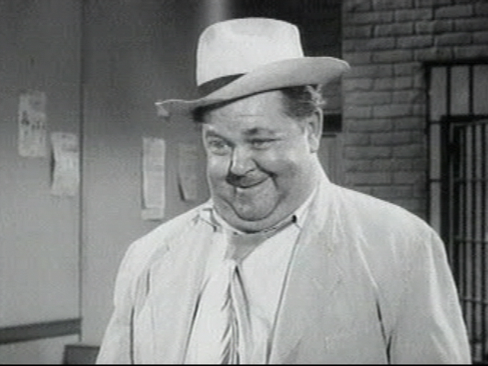
2006 Otis Invitational

Official Otis Rules

Unless otherwise stated by the rules committee (Jason, Bump and Mike), USGA rules apply. Here are some clarifications and local rules that should help eliminate confusion.

SHOW UP!
We go through a lot of planning to set up the Otis each year, so if you cannot make it, please do everything possible to tell us early and we will try to find a replacement. Uneven scramble teams are not fun for anybody. If you play, you will be among the first to get invited back every year!

PLAY WHEN YOU ARE SCHEDULED!

It is difficult to set up the tee times so that people do not play with the same foursome every day, and still
keep teams fairly even. If you cannot play in the first or last tee time Sunday morning, you are not Otis material and you should stay home! Even though your odds are good that you will play when you want, be prepared to stick it out until the last minute. Do not assume you can get home early on Sunday. Make your travel plans accordingly. You have been warned.

NO COMPLAINING about the conditions or rules!

NO GIMMIES!

KEEP PACE:
Please take no more than 10 strokes per hole. If you hit the ball 10 times and are still not in the hole,
give it up and move on!
Please keep up with the group ahead of you. We need to get a lot of people through the course in time
to tee off again in the afternoon, and we do not want dinner to be later than it has to be.

RAIN:
You are expected to play through all weather. We follow a modified Otis rule.(The original Otis rule is, if the bar is open, you must drink!), thus the modified rule is: if the course is open you must play. With this in mind, be prepared with an umbrella, rain suit, multiple towels, and spare gloves. As Bill Murray would say, “I don’t think the hard stuff will come down for a while” Remember, we are coming a long way to play, so be prepared! Besides, everyone will face the same conditions.

SHIRTS & SHOES:
Soft Spike shoes are required. Most of us have converted by now, but it is still worth mentioning. Please wear shirts with a collar.

TEE TIMES
Arrive at least 20 minutes before your morning tee time.

MOVING THE BALL:
Fairway and Rough- You are allowed to move the ball no more than six inches

OUT OF BOUNDS:
All Courses - All holes - you are allowed to drop the ball where it went OB with a ONE stroke penalty.

If the ball is OB but playable, you still must drop it back in play and take the one stroke penalty!

LOST BALLS: (This year’s honoree is Brandan Mueller, who is missing this year’s Otis to get married…) You may drop a ball in the area where you think the ball disappeared (you must get agreement from your partners on the spot), and then take a ONE stroke penalty.

WATER HAZARDS:
Standard - Drop where the ball crossed the margin of the hazard, one stroke penalty (i.e., on a par 3
if you hit your tee shot in the water, after your drop, you will be hitting your 3rd shot.)
Exceptions - #4 at Thornapple: Off the tee, drop on the other side of the marsh by the cart path
#5 at Thornapple: Off the tee, drop on the other side of the lake directly in front of the tee
#17 at Thornapple: Off the tee, drop in the official drop area (if marked), otherwise,
drop just short and to the right of the green.
#11 at Heritage Off the tee, drop on the other side of the marsh.
#16 at Heritage Off the tee, drop on the other side of the lake.

SCORECARDS:
Must be signed by each member of the group and given to Zim after each round.

SCRAMBLES:
Drives: Minimum of 2 drives must be used from each player
Position - You must hit your shot within 1 club length of where the ball was marked. You can
not change the playing surface (i.e., if you are in the rough or sand you must play the ball from
the rough or sand). Also, you may not move the ball closer to the hole.
Putting: Once the ball is in the hole, that is your score (i.e., DON’T tap the ball in if someone else still
has a chance to make the putt!!)
Finish: Weather permitting, wait at least 30 feet behind the green for the following groups.

Friday Morning Individual Score
(Shotgun start – everyone needs to tee off at 7:45 AM!)
Name | Otis Score
Ron Blink | 81
John Steffensen | 88
Jordan Zimberoff | 93
Steve Rehfeldt | 105
Bill Krueger | 81
Lance Murphy | 100
Mike Reda | 97
Joe Booth | 100
Adam Kommers | 85
Phil Joschko | 100
Tim Monti | 99
Rob Rains | 112
Tom Westerholm | 91
Bill Wahl | 94
Paul Hanson | 100
Mike Redenbaugh | 87
Jay Huseth | 85
Pat Mackey | 96
Mark Lutz | 105
Jason Zimberoff | 93
Steve Ryan | 89
Larry Ryan | 94
Jeff Lake | 93
John Wucki | 100
Dave Compton | 94
Pat DiDomenico | 98
John Hayes | 105
Darryl Krumwiede | 94
Mark Fankhanel | 93
Kai Bobkowski | 92
John Iannantuoni | 100
Scott Kossman | 109
Friday Afternoon Scramble
Name Otis Score
Ron Blink | 81 | 0
Darryl Krumwiede | 94 | 3
John Wucki | 100 | 4
Rob Westover | 110 | 6
Bill Krueger | 81 | 0
Lance Murphy | 100 | 4
Joe Booth | 100 | 4
Randy Comstock | 114 | 6
Adam Kommers | 85 | 1
Jason Zimberoff | 93 | 3
Bump Waghorne | 100 | 4
Rob Rains | 112 | 6
Mike Redenbaugh | 87 | 1
Jordan Zimberoff | 93 | 3
Larry Ryan | 94 | 3
Scott Kossman | 109 | 6
Jay Huseth | 85 | 2
Pat Mackey | 96 | 4
Jeff Lake | 93 | 3
Mark Lutz | 105 | 5
Steve Ryan | 89 | 2
Dave Compton | 94 | 3
Paul Hanson | 100 | 4
Steve Rehfeldt | 105 | 5
John Steffensen | 88 | 2
Bill Wahl | 94 | 3
Jack Westover | 92 | 3
John Hayes | 105 | 5
Tom Westerholm | 91 | 2
Pat DiDomenico | 98 | 4
Tim Monti | 99 | 4
Phil Joschko | 100 | 4
Kai Bobkowski | 92 | 3
Mark Fankhanel | 93 | 3
Mike Reda | 97 | 4
John Iannantuoni | 100 | 4

Saturday Morning Individual Score
(Shotgun Start – Everyone needs to tee Off At 7:45!)
Name | Otis Score
Ron Blink | 81
Phil Joschko | 100
Mark Lutz | 105
Scott Kossman | 109
Bill Krueger | 81
Kai Bobkowski | 92
John Iannantuoni | 100
Rob Rains | 112
Adam Kommers | 85
John Steffensen | 88
Jordan Zimberoff | 93
Mike Reda | 97
Tom Westerholm | 91
Pat Mackey | 96
Larry Ryan | 94
Joe Booth | 100
Jay Huseth | 85
Bill Wahl | 94
Pat DiDomenico | 98
John Wucki | 100
Steve Ryan | 89
John Hayes | 105
Tim Monti | 99
Darryl Krumwiede | 94
Dave Compton | 93
Mike Redenbaugh / Zim | 87 / 93
Jeff Lake | 93
Jack Westover | 92
Mark Fankhanel | 93
Paul Hanson | 100
Lance Murphy | 100
Steve Rehfeldt | 105

Saturday Afternoon Scramble
Name HCP Team HCP
Ron Blink | 0
Tim Monti | 4
Dave Compton | 3
Rob Rains | 6 | 13
Bill Krueger | 1
Larry Ryan | 3
John Wucki | 4
Scott Kossman | 6 | 14
Mike Redenbaugh | 1
Phil Joschko | 4
Bump Waghorne | 4
Rob Westover | 6 | 15
Adam Kommers | 1
Jack Westover | 3
Pat Mackey | 4
Steve Rehfeldt | 5 | 13
Jay Huseth | 2
Jason Zimberoff | 3
Joe Booth | 4
Mike Reda | 4 | 13
Steve Ryan | 2
Jeff Lake | 2
Paul Hanson | 4
Randy Comstock | 6 | 14
John Steffensen | 2
Mark Fankhanel | 3
Pat DiDomenico | 4
John Iannantuoni | 4 | 13
Tom Westerholm | 3
Jordan Zimberoff | 3
Darryl Krumwiede | 3
Mark Lutz | 5 | 14
Kai Bobkowski | 3
Bill Wahl | 3
John Hayes | 5
Lance Murphy | 4 | 15

Sunday Morning Scramble
(Shotgun start – everyone needs to tee off at 7:30!)

Name
Ron Blink | 0
Darryl Krumwiede | 3
Bump Waghorne | 4
Randy Comstock | 6 | 13
Bill Krueger | 1
Jason Zimberoff | 3
Mike Reda | 4
Steve Rehfeldt | 5 | 13
Mike Redenbaugh | 1
Pat Mackey | 4
Tim Monti | 4
Mark Lutz | 5 | 14
Adam Kommers | 1
Jack Westover | 3
Pat DiDomenico | 4
Rob Westover | 6 | 14
Jay Huseth | 2
Larry Ryan | 3
Joe Booth | 4
Paul Hanson | 4 | 13
Steve Ryan | 2
Mark Fankhanel | 3
Lance Murphy | 4
Rob Rains | 6 | 15
John Steffensen | 2
Jordan Zimberoff | 3
Phil Joschko | 4
John Iannantuoni | 4 | 13
Tom Westerholm | 3
Bill Wahl | 3
John Wucki | 4
John Hayes | 5 | 15
Kai Bobkowski | 3
Jeff Lake | 2
Dave Compton | 3
Scott Kossman | 6 | 14

Player Bios

This is the famous Otis Bio section. If you have a better nickname, tell

Bump, Rob, Mike, or Zim and we will change it next time...

Score Name Otis Nickname Information

81 Ron Blink “Fade” Ron played great in his first Otis last year, earning him a tie for the top spot this year. And
although he played great in the mornings, rumor has it that he started to fade each
afternoon as his blood alcohol content increased. Look for him to sink more incredible
shots this year– both golf and tequila.

81 Bill Krueger “Billy Baroo” Billy returned to form last year, both in the quality of his play, and the decibels of his voice.
But many were wondering what he was yelling about at 8:10 AM. Hey Bill – why not save it
for the afternoons when everyone else is awake?

85 Jay Huseth “JayBird” Jay joins this year's Otis for his rookie debut. Make no mistake however, this man is
no rookie golfer. Well known for his soft touch around the greens and long reach from the
tees Jay specializes in sandbagging his way into huge handicap scores in various outings
such as these. His only weakness is the fact that he hails from the great state of
Wisconsin and feels obliged to support the state's fledgling sports teams. So for those
looking to make a little cash on the side, take Jay's money on the Packer's game and
leave the golf bets to others...

85 Adam Kommers “Rowdy Roddy Piper” Adam is now father with a full time job and two kids. Now he has a boy and a girl too.
Running for Father of the Year, he is playing in this Otis only 3 weeks after the birth of his
daughter. Look for Adam to deteriorate slowly as the weekend progresses – with the
implosion finally coming on Sunday.

87 Mike Redenbaugh “Rusty” Only appearing in his old form briefly last year (when Greg Wilson’s money was at stake),
Mike has not played since the Otis last year. Having moved back to the Chicago area, he is hoping to find the time to work on his game again someday - maybe in about 17 years when his daughter finally goes away to college.

88 John Steffensen “The Iron Man” Returning for his 4th Otis, you will rarely catch John with a driver in his hand. Preferring to
play it safe and use his irons exclusively, don’t be surprised to learn that he doesn’t really
need the woods! John is also the undisputed #1 Lefty in the field!

89 Steve Ryan “The Putt” The newest A player in the group, this member of the “Ryan Ringers” has found his game
recently. Let’s see if he can handle the pressure of being the go-to guy on his scramble
teams this year!

91 Tom Westerholm "Playoff" Returning for his third Otis, Tom has been able to get his team to the playoffs in at least
one scramble each of his first two years. He won once, and lost once. Lets see if we can
keep him on the sidelines instead this year!

92 Kai Bobkowski “Kai Bob” After missing last year’s Otis, Kai is returning to Kalamazoo to try to find his old form.
Look for Kai to find his game in the scrambles – after he gets “loose” during the morning
rounds with his friends Jose, Jack, and Jim.

92 Jack Westover “Bail Out” A last-second sub this year, Jack is bailing us out by playing on short notice. However,
being a long time veteran of the Otis, don’t mistake his nickname for a description of his
golf swing. He has A player experience and should be a dangerous high B player this
year.

93 Jason Zimberoff “Mustang” Zim is now spending more time tinkering with his Mustang than he ever did with his golf
game. And after buying and selling another one for a $100 loss this spring, he is ready to
get his mind back on golf this week.

93 Jeff Lake “Mr. Demo Day” A wise old golfer once said that the answer to one’s golf woes was “take two weeks off –
and then quit.” Jeff has a different philosophy – “take two weeks off – and then replace all
of your golf clubs”. This year’s addition – a custom one-of-a-kind driver engraved with his
name. If only he was good enough to merit putting his name on the bag too…

93 Jordan Zimberoff “Little Zim” Jordan is finally done with grad school and is now the newest history teacher at Fenton
high school in Bensenville. But he will need to work on his game now that he has the
summers off. If we had an award for “longest drive straight up in the air” Jordan would win
it every time. Distance off the tee is not too bad, but wow – what hang time!

93 Mark Fankhanel "Mr. Sunscreen" We expect great things from Mark this year. With two kids now going to school at
Marquette, and all that extra time to practice without them at home, he should improve close to the level of an A player this year – and, he also needs to play well so that he can
win some cash to buy gas for the trip home.

94 Dave Compton “Land Barron” Dave is a new property owner down at Kentucky Lake, and is now calling himself the “Land
Barron”. It’s good, because now he has an extra house to store all of the golf clubs he has
bought over the years, but its bad because too much fishing and not enough golfing is sure
to hurt his Otis chances this year. Maybe you can fit one of those 3 irons with a bait-
casting reel?

94 Larry Ryan “The Ringleader” Larry used to be the low Ryan on the board from the “Ryan’s Ringers” group, but he has
now been passed up by his brother Steve. Will another return to Kalamazoo bring back
the glory days? Or are we doomed to watch with him as Steve accepts another envelope
full of cash?

96 Bill Wahl “The Set Up Man” Bill found his golf game in the scramble on Saturday last year when he went back to his old
swing (the Ryan ringers had convinced him he needed to change his swing, and he went
into a David Duval type funk) but Baugh brought him out of it, and much cash was their
reward. Which swing will Bill bring to the Otis this year?

94 Darryl Krumwiede “Brother Darryl” The Otis gods were correct last year. Even though the quietest member of the Ryan
Ringers had a bad year in ’04, we kept his score the same in ’05 and he returned to his
normal self. Will he continue the improvement in ’06 or will the enigmatic Darryl throw us
another curveball?

96 Pat Mackey "Late Night" Pat was last year’s Otis Poster Boy after drinking with the Black Widow in the hotel parking
lot until 4am. Amazingly, besides wearing glasses, sweating profusely, and looking dis-
sheveled, Pat was able to function somewhat normally during Sundays round. It's likely
that the alcohol in his cologne was enough to get his buzz back.

97 Mike Reda “Choke” After a bad year in ’04, we wondered if Choke was beginning to head towards the Otis
cellar, or if he would reawaken play like his old self. The really low scores of days gone by
were not found, but he did beat his Otis score by 6 for the whole weekend last year.
Continued improvement could be coming – so watch out!

98 Pat DiDomenico “Dee-Doe” Another year, another prediction of Otis success. Pat claims to be playing better lately,
and looks to win some low net money this year. Why is his score still at 99? Well, this is
pretty much the same thing we said last year too. Good luck!

99 Tim Monti “Coach” Coach is going to miss his friend, the "Black Widow" (Brandan) this year (Brandan has a
pretty good excuse, though, he's getting married). He also is finally joining the 21st century
with a new driver this year, so hopefully he will be spending more quality time in the fairway
and less time off-roading. If he can straighten out his slice, look out!!

100 John Wucki “Chewy” John showed some life in the Otis last year, coming in a full 12 shots under his score for
the weekend. If he improves again this year, we might just be forced to move him up into
the 90’s for his Otis score. Next goal – passing Jeff Lake and Jack Westover for low man
from Glen Ellyn.

100 Paul Hanson “Slap Shot” Paul belongs to Midlothian Country Club (a real members-only type place) and reports that
he plays all the time. And – um – he is still in the Otis ranked at 100. Perhaps he is spending a little too much time with Judge Smails on the Yacht.

100 Lance Murphy “Murph” Lance had originally planned a family vacation in Disney World this weekend, but is now
delaying his departure so that he can still participate in his one true love – a night at
Mermaids. (Just kidding) But a Mickey Mouse hat with ears: $5.00. A dinner at Epcot
Center: $20. Making the family wait to go on vacation so that you don’t miss the Otis?
Priceless.

100 John Iannantuoni “Johnny Credit” John is another golf practice junkie. His wife claims that he is always out working on his
game. So why has he been stuck around 100 since he first came to Kalamazoo? Maybe
he needs new clubs. Maybe it’s the golf ball. Maybe it’s that Bump makes him nervous.
Or, maybe its just because he really should consider taking up tennis.

100 Phil Joschko “Mr. Mermaid” Every year we use this space to talk about Mermaids’ #1 customer, so this year we are
going to try to talk about something else he did in Michigan last year. Anyone? Anyone? Bueller?

100 Joe Booth “Jo Mamma” Joe recently starting working at an Amish furniture shop as their head salesman. We
wanted to let him know that we were also playing a practice round on Thursday this week,
but we called too late. It seems that he had to leave on May 22 so that the horse and
buggy could get him to Kalamazoo on time.

100 Bump Waghorne “Sweet Swingin’ ” Bump, Sweet Swingin’ Willie T. Wags & Mr. Sunday, all are actually the same person –
and he will need to get that back stretched out to see if he can get into the money this year. Even though he has been one of the Otis organizers for years, we had to take a
vote to see if he could come back and play after missing last year. As our friend Robert
Montgomery Westover says – “Thank god there’s only one of him”.
105 Steve Rehfeldt “Radar” His job has not allowed Steve any time to work on his game lately, but that’s ok because
he is guaranteed to be the low Rehfeldt on the leader board after every round this year.
Just don’t tell him that it’s because his brother Bryan had to miss the Otis this year.

105 John Hayes “The Anchor Man” As John arrives for another Otis, we wonder if his best golf days are behind him now.
Which would be too bad because his best golf days were when we had him ranked at 102.

105 Mark Lutz "Buckeye" Will Lutzy perform like his Buckeyes, showing flashes of greatness early then slumping
late? The odds look good for a full slump as he has been spending 3 hours a day
driving back and forth to work (not counting the 12 hours a day he puts in) and not getting
a lot of time to work on that golf game. Looks like Michigan will once again put a damper
on this Buckeye’s weekend.

109 Scott Kossman “Koss” Scott blew off a sales meeting last year so that he could come up a day early and practice
before the Otis. He participated in the meeting over the phone from the course, after being
perhaps a bit over served. Let’s just say that the meeting went over so well, that they
asked him to stay in Chicago and attend it in person this year! See you after the meeting!

110 Rob Westover “Big Rob” After taking a few lessons this spring, Robert Montgomery is confident that he still has the
ability to break 100. While we are not sure if that means 100 strokes, or 100 tree
branches, we wish him the best. We are moving him down to 110 this year just on the
merits of his own optimism. Will he be able to cash in? Or will he have to ride on the
coattails of his fellow “Team Buffet” members? Stay tuned…

112 Rob Rains “Big Rob II” Rob is back again to defend his title as low “Big Rob” in the group, after another convincing
one shot victory last year. A one shot victory over his fellow “Team Buffet” member might
not seem like much but… well, we guess it isn’t much actually…

114 Randy Comstock "Burgertime" Randy was found complaining last year that someone had ordered him a hamburger for
lunch. “I never order hamburgers!” he was heard to say… Problem was, he had already
eaten half of it by then. We would usually insert a golf story here, but rumor has it that there were not too many memorable moments in that category. Better luck this year!

Otis Invitational History

Long ago there was a group of guys who played golf on Sunday Mornings at Arrowhead golf course in Wheaton. One of them was Terry Bulger, who worked for a bank in Chicago. One day (sometime in the late ‘80’s ) Terry asked two of his golfing partners - Ken Redenbaugh and his son Mike – if they would like to join him in a golf outing run by some of the guys he worked with at the bank.

These two co-workers had organized a golf outing in Kalamazoo Michigan at Thornapple Creek golf course, and played 90 holes there in three days. The group made up of mostly bank employees and their friends was called the Lapski – after its co-organizers named Gonski and Lapitina.

Back then, Thornapple was a course unlike any that they had seen. Rolling terrain, a great layout with lots of trouble, and unbelievably fast greens. It was truly a golf paradise.

Terry, Mike and Ken played in the Lapski for a number of years – occasionally adding a few other neighbors and friends to the group. Eventually, Mike asked his friend Jason Zimberoff to join the group.

By this time, the Lapski group had grown to about 40 men, but the quality of the greens at Thornapple started to fall off from the glory days. So, they had also added another course to the schedule on Saturdays, called Heritage Glen. The Friday and Sunday rounds were still played at Thornapple though.

The Lapski golfers were also more serious about the winning and scoring, and it sometimes led to a lot of under-the-breath muttering about sandbaggers and people not following the rules. It did sometimes take away from what we thought the spirit of the trip should be.

With the addition of Jason Zimberoff also came many of his friends and family members. After a couple of
years, Mike and Jason were bringing at least 12 guys to Michigan with them to play in the Lapski – and a great time was had by all…

Until one dark day at the beginning of 1998, Mike got the phone call that changed history forever. The Lapski group wanted to go back to inviting more of the bank employees and more of their friends, and we were asked to only bring 4 players that coming summer.

That was all we needed to hear. How could we choose who could and couldn’t go? Would we hang our heads and agree to this? NO!

The group of Mike Redenbaugh, Jason Zimberoff, Bump Waghorne, and Rob Westover, all former Lapski players, decided to create a new outing based on the self-described “Oti” (pronounced oat-eye) club of over-served
drinking buddies… named, of course, after everyone’s favorite town drunk – Otis Campbell of Mayberry.

We immediately got together and came up with the idea for the Otis Invitational. A group that would be made up of all of our friends and family. Although we did bring many of the long-time Lapski guys with us, we hope that we left all of the bickering and BS with the old group. We even replaced the Sunday individual scoring round with a scramble to make it more fun – along with a few other minor changes that we all wanted to make.

This year, we again return to Kalamazoo with 36 of our own players, and three golf courses! We wouldn’t have it any other way. Thanks to everybody who has participated these nine years, and here’s to 50 more!

Directions to the Holiday Inn from Chicago

Take the tri-state toll way south towards Indiana.
Follow 294 south to 80-94 east.
Stay on I-94 all the way into Michigan and to Kalamazoo.
Exit I-94 on US 131 North.
Follow US 131 North to exit 36B (west Stadium Drive).
Go west on Stadium Drive to the first stoplight (11th St).
Turn Left, and follow street one block to the
hotel your left.

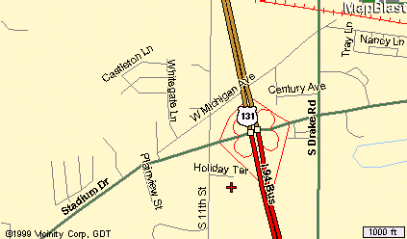

Holiday Inn (Kalamazoo West)
2747 S. 11th St.
KALAMAZOO, MI 49009
Tel: 1-269-375-6000
Fax: 1-269-375-1220
Check-In Time: 4:00 PM
Check-Out Time: 11:00 AM

Gallagher’s (Formerly Chianti’s)
Gallagher’s is on Stadium Drive, about 1 mile east of the hotel.
4210 Stadium Drive
Kalamazoo, MI 49008
(269) 372-7177

Directions to The Lynx Golf Course from Holiday Inn

Take 11th st. North to Staduim, then turn right.
Take Staduim to US 131 and get on going north.
Follow US 131 north out of town to
Michigan State Road 89 (M89) west.
Follow M89 west through the small town of Otsego
and veer right still following M89.
The golf course will be on your left,
1 or 2 miles outside of town.

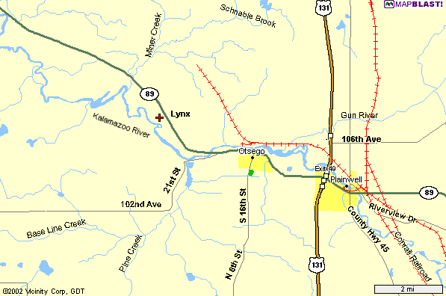

Lynx Golf Course

900 Lincoln Road (M89)

Otsego, Michigan 49078
1-269-694-5969
Directions to Thornapple Creek from Holiday Inn

Follow 11th St north to Stadium Av. Turn Right.
Follow Stadium Ave east to Drake Rd.
Turn Left on Drake and drive a few miles north to Ravine Rd.
Turn left on Ravine Rd. And follow it to “F” Ave.
Turn left on “F” Ave and follow to Thornapple, on the left side of the road.

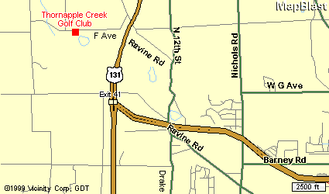

Thornapple Creek Golf Club
6415 W. F Ave
Kalamazoo, MI 49009
1-269-344-0040

(Alternate route to Thornapple from Holiday Inn)
Get on to US 131 North as above and follow it to the exit for “D” Ave.
Turn left onto D Ave, and drive 1 mile to Ravine Rd.
Turn left on Ravine Rd, and begin driving back south.
Follow the left fork to stay on Ravine Rd, and follow it to “F” Ave.
Turn right on “F” Ave. And follow it to Thornapple which will be on the left.
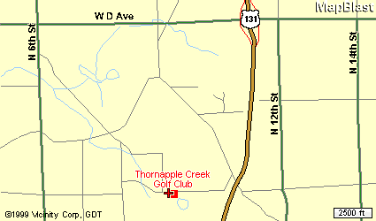

Directions to Heritage Glen from Holiday Inn

Take 11th St. north to Stadium Av. Turn Left.
Follow Stadium Drive west out of town.
Stadium will become “Red Arrow Highway”.
Follow Red Arrow Hwy west to 30th Street.
(Be patient, it is a few miles)
Turn right on 30th St. And follow to Heritage, about 1 or 2 miles down on right.

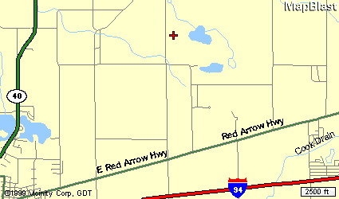

Heritage Glen Golf Club
29795 Heritage Lane
Paw Paw, MI 49079
1-269-657-2552



Lynx Golf Course

900 Lincoln Road (M89)

Otsego, Michigan 49078
(269) 694-5969

The clubhouse sets 135 feet above the river and the course meanders up and down the rolling hills that the property encompasses. The 8th hole is a par 5 with the green elevated 95 feet above the tee.
The par 4 10th hole offers 85 feet of drop from the tee to the fairway!

Many other holes offer elevation changes and breath taking scenic views that will remind the
golfer of their favorite Northern Michigan course.

Each hole is isolated by itself and gives the golfer the opportunity to enjoy the peace and solitude of the great outdoors. Most of the course is surrounded by river bottom land owned by the State of Michigan.
Thus, the course will always provide the peaceful solitude of a golf course in the woods.
At the Lynx, our golf holes are lined by a river and trees, not houses!

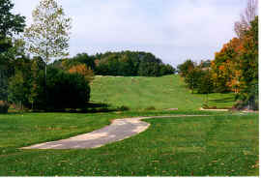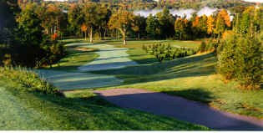

Blue Tees: Course Rating 71.2, Slope 137, 6471 yards
White Tees: Course Rating 69.1, Slope 134, 6012 yards



Thornapple Creek Golf Club
6415 West “F” Ave.
Kalamazoo, MI 49009
(269) 344-0040

Rated one of the most challenging courses by the Golf Association of Michigan. Enjoy a rare
combination of undisturbed natural beauty and finely manicured bent grass, a treat for any
golfer. The Creek’s 13th hole, a 618 yard par 5, was ranked as the best par 5 in the state, and
was also named to the Detroit Free Press’ “Dream 18”.

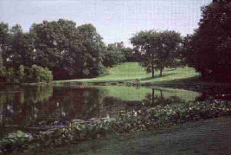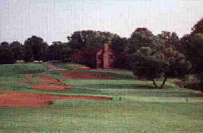

After your round enjoy the rustic log cabin clubhouse. Complete food and beverage service and
large seating capacity make it the ideal setting for heckling your fellow Otis participants as they
putt out on the 18th hole.

Blue Tees: Course Rating 72.3, Slope 133, 6595 yards
White Tees: Course Rating 70.0, Slope 127, 6122 yards


Heritage Glen Golf Club
29795 Heritage Lane
Paw Paw, MI 49079
(269) 657-2552

A challenging, public 18-hole, par 72 layout built on 235 acres of beautiful, rolling land in southwestern Michigan’s wine region. Opened in 1994, it is located five miles northeast of Paw Paw.

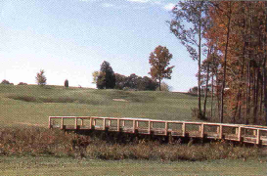
(The Adam Kommers Memorial Bridge)

On this beautifully maintained course, golfers enjoy three different settings on the front nine alone - pines, hardwoods, and a bit of the links effect. The bent grass greens, fairways, and tees are superbly manicured. Golfers need to make their mark on the front, because they wont be able to let up at all on the back nine!

The 6th hole is 625 yards from the back tees. It’s a narrow, double dogleg test that requires your best shot making ability.

Blue Tees: Course Rating 72.1, Slope 137, 6630 yards
White Tees: Course Rating 69.2, Slope 131, 6049 yards

